**MAHARAJA SURAJMAL INSTITUTE**

C-4, JanakPuri, New Delhi, 110058



DEPARTMENT OF COMPUTER APPLICATION

WEB TECHNOLOGY LAB

SUBJECT CODE-BCA-105P

**Submitted by:** **Submitted to:**

**Name:** Krishna Ms. Rhythm Choudhary

**Enrollment No.: -** Assistant Professor

00214902020 MSI

**Course:** BCA-I-A

(Shift 1)

**INDEX**

|  |  |  |
| --- | --- | --- |
| **S.no** | **List of Program** | **Sign.** |
| 1. | Create your Web Page on India using various basic HTML tags. |  |
| 2. | Create an Restaurant Menu That use Ordered list, Unorder List, definition list, Nested list. |  |
| 3. | Design a table and make use of following attributes:  colspan, rowspan, thead, tbody, tfoot, width, height, cellpadding, cellspacing etc. |  |
| 4. | Create Student registration form for admission in college. |  |
| 5 | Create a web page showing India's map and create hotspots on five different states and link them to the  e-Government sites of the respective states. |  |
| 6. | Create a web page using four frames and link them to an image, web page  audio and video. |  |
| 7. | Create an Iframe and write some lines before and after it. |  |
| 8. | Create 3 similar webpage with inline and internal style sheet and external  style sheet and apply all Text styling attributes. |  |
| 9. | Make a Web page that uses all the following pseudo classes. Hover, active, focus, visited. |  |
| 10. | Create a web page that use Id and class selector. |  |
| 11. | Create separate web pages containing:  I. Container Class  II. Grid  III. Tables  IV. Image  V. Button  VI. Typography  VII. Jumbotron  VIII. Glyphicons |  |
| 12. | WAP to make use of JavaScript Operator: :  I. Arithmetic Operators  II. Assignment Operators  III. Comparison Operators  IV. Logical Operators  V. Conditional Operators  VI. Type Operators  VII. Bitwise Operators |  |
| 13. | WAP to make use of following JavaScript Statements:  i.if  ii. else  iii. else if  iv. switch  v. while  vi. do while  vii. for  viii. for in  ix. for of |  |
| 14. | WAP to show use of following object in JS.  i.date  ii.Math  iii.string |  |
| 15. | WAP to show use of object in JavaScript.  i. By object literal  ii. By instance of object directly  iii. By using object constructor |  |
| 16. | WAP to show Validation in JavaScript. |  |
| 17. | WAP to show usage of inbuilt functions. |  |
| 18 | WAP to show usage of  i. alert box  ii. prompt box  iii. comfirm box. |  |
| 19 | WAP demonstrating  i. Factorial of number  ii. Prime number in a range  iii. Reverse of a number |  |
| 20. | WAP to implement event handling using  i. onclick  ii. mouseover  iii. mouseout  iv. mousein  v. doubleclick  vi. mousemove |  |
| 21. | WAP in JavaScript to demonstrate  i. Blur  ii. Focus  iii. Reset  iv. Submit  v. Change  vi. load |  |
| 22. | WAP to implement event handling using  i. keydown  ii. keyup |  |
| 23. | WAP to show JS can change HTML content. |  |
| 24. | WAP to show JS can change HTML attribute value. |  |
| 25. | WAP to show JS can change HTML style. |  |
| 26. | WAP to show use of Window Object in JS.  i. Navigation object  ii. JavaScript Screen Object  iii. Set-time function |  |
| 27. | Create an XML file containing note as the root element and to, from, subject and body as its child element. |  |
| 28. | Create a well-formed XML file having 5 tags-food menu, category, name, price and calories. Food_menu is the main parent element that contains category as the child element. Category is the parent element of name, price and calories. |  |
| 29. | WAP to display the bookstore details in XML with CSS and internal DTD. |  |
| 30. | Create Valid XML doc using external DTD. |  |

**Program 1 : Create your Web Page on India using various basic HTML tags. Index.html page**  
<!DOCTYPE html>  
<html lang="en">  
<head>  
 <meta charset="UTF-8">  
 <meta name="viewport" content="width=device-width, initial-scale=1.0">  
 <title>All About India</title>  
 <style>  
 body {  
 font-family: Arial, sans-serif;  
 line-height: 1.6;  
 margin: 20px;  
 }  
 h1 {  
 color: #2c3e50;  
 }  
 h2 {  
 color: #2980b9;  
 }  
 .highlight {  
 background-color: #f9e79f;  
 padding: 5px;  
 }  
 </style>  
</head>  
<body>  
  
<h1>Welcome to India</h1>  
  
<p>India is a country in South Asia. It is the seventh-largest country by land area, the second-most populous country, and the most populous democracy in the world.</p>  
  
<h2>Geography</h2>  
<p>India is known for its diverse geography. It has:</p>  
<ul>  
 <li>Mountains (Himalayas)</li>  
 <li>Deserts (Thar Desert)</li>  
 <li>Rivers (Ganges, Yamuna)</li>  
 <li>Coastlines (Arabian Sea and Bay of Bengal)</li>  
</ul>  
  
<h2>Culture</h2>  
<p>India has a rich cultural heritage. Some key aspects include:</p>  
<ol>  
 <li><strong>Languages:</strong> India has 22 officially recognized languages.</li>  
 <li><strong>Festivals:</strong> Major festivals include Diwali, Holi, Eid, and Christmas.</li>  
 <li><strong>Cuisine:</strong> Known for its spices and variety, Indian cuisine varies by region.</li>  
</ol>  
  
<h2>Tourist Attractions</h2>  
<p>Some popular tourist destinations in India are:</p>  
<ul>  
 <li>The Taj Mahal</li>  
 <li>The Red Fort</li>  
 <li>The beaches of Goa</li>  
 <li>The backwaters of Kerala</li>  
</ul>  
  
<img src="https://upload.wikimedia.org/wikipedia/commons/thumb/4/41/Taj_Mahal%2C_Agra%2C_India.jpg/800px-Taj_Mahal%2C_Agra%2C_India.jpg" alt="Taj Mahal" style="width:100%; max-width:600px;">  
  
<h2 class="highlight">Interesting Facts</h2>  
<p>Here are some interesting facts about India:</p>  
<ul>  
 <li>The Indian Railways is one of the largest railway networks in the world.</li>  
 <li>India is home to the world's highest cricket ground.</li>  
 <li>The country has a rich tradition of yoga and meditation.</li>  
</ul>  
  
<h2>Visit India!</h2>  
<p>If you want to learn more about India or plan a visit, check out the official tourism website:   
 <a href="https://www.incredibleindia.org" target="_blank">Incredible India</a>.  
</p>  
  
<hr>  
  
<footer>  
 <p>&copy; 2024 All About India. All rights reserved.</p>  
</footer>  
  
</body>  
</html>

**Output**

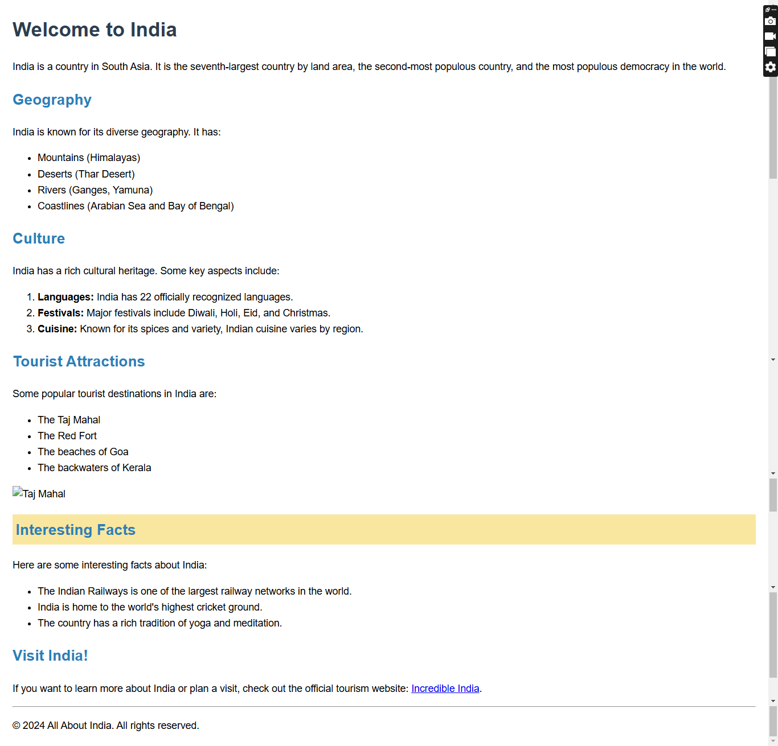

**Program 2: Create an Restaurant Menu That use Ordered list, Unorder List, definition list, Nested list.**

**Index.html Page**  
<!DOCTYPE html>  
<html lang="en">  
<head>  
 <meta charset="UTF-8">  
 <meta name="viewport" content="width=device-width, initial-scale=1.0">  
 <title>Restaurant menu</title>  
 <style>  
 body{  
 background-image: url(https://png.pngtree.com/thumb_back/fw800/background/20230927/pngtree-white-grey-minimalist-creative-page-border-image_13370233.jpg);  
 background-size: cover;  
 background-position: center center;  
 background-repeat: no-repeat;  
 font-size:20px;  
 }  
 .content{  
 margin-left: 10vw;  
 margin-right: 10vw;  
 }  
 </style>  
</head>  
<body>  
 <h1 align="center">   
 <font style="font-family:'Segoe UI';"><u>Restaurant Menu </u></font>  
 </h1>  
 <div class="content">  
 <h2>Vegetarian</h2>  
 <dl>  
 <B><dt>Vegetarian Delights : </dt></B>  
 <dd>Indulge in our vibrant selection of plant-based dishes, featuring fresh ingredients and authentic spices that celebrate the rich flavors of Indian cuisine.</dd>  
 <B><dt>Wholesome Veg Options:</dt></B>  
 <dd>Savor our hearty vegetarian offerings, from creamy curries to crispy snacks, crafted to satisfy every palate while embracing the essence of traditional Indian flavors.</dd>  
 </dl>  
 <ol>  
 <B><li>Starters</li></B>  
 <ul>  
 <li>Papadom</li>  
 <li>Samosa</li>  
 <li>vegetable Pakora</li>  
 </ul>  
 <B><li>Vegetable Dishes</li></B>  
 <ul>  
 <li>Chana Masala</li>  
 <li>Bombay Long</li>  
 <li>Tarka Daal</li>  
 <li>Bangan Bharta</li>  
 </ul>  
 <B><li>Rice</li></B>  
 <ul>  
 <li>Plain rice</li>  
 <li>Mushroom Rice</li>  
 <li>Garlic rice</li>  
 <li>Biryani</li>  
 </ul>  
 <B><li>Curry</li></B>  
 <ul>  
 <li>Madras</li>  
 <li>Karakhi</li>  
 <li>Balti</li>  
 <li>Saag</li>  
 </ul>  
 <B><li>Breads</li></B>  
 <ul>  
 <li>Garlic Naan</li>  
 <li>Peshwari Naan</li>  
 <li>Garlic and Onion</li>  
 <li>Tandoori Roti</li>  
 <li>Chips</li>  
 </ul>  
 </ol>  
 </div>  
</body>  
</html>

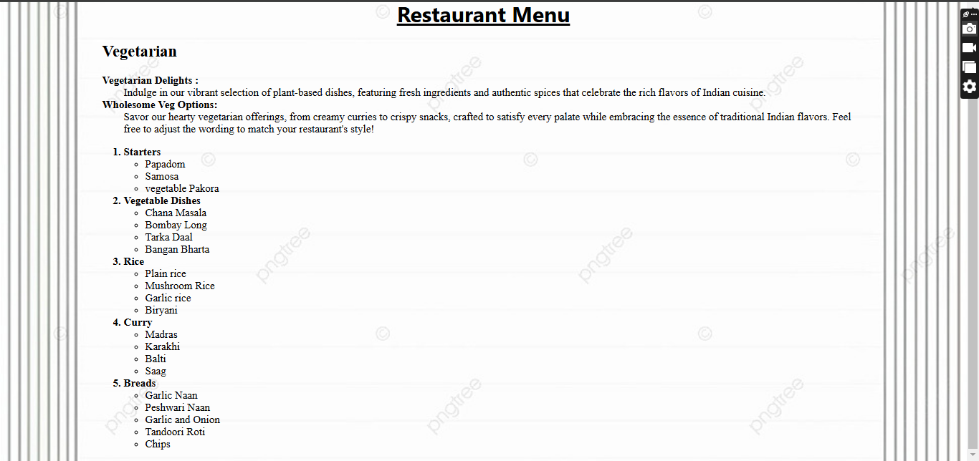**Output**

**Program 3: Design a table and make use of following attributes:**

**colspan, rowspan, thead, tbody, tfoot, width, height, cellpadding, cellspacing etc.**

**Index.html Page**  
<!DOCTYPE html>  
<html lang="en">  
<head>  
 <meta charset="UTF-8">  
 <meta name="viewport" content="width=device-width, initial-scale=1.0">  
 <title>Tables</title>  
</head>  
<body>  
 <h1 align="center">TABLE AND ITS ATTRIBUTES</h1>  
 <center><table width="80%" border="2px" cellpadding="10px">  
 <colgroup>  
 <col span="5" style="background-color: aliceblue;">  
 <col style="background: greenyellow;">  
 </colgroup>  
 <thead style="background-color: aqua;">  
 <tr>  
 <th rowspan="2">NAME</th>  
 <th colspan="5">SUBJECTS</th>  
 </tr>  
 <tr>  
 <th>English</th>  
 <th>Hindi</th>  
 <th>Maths</th>  
 <th>Science</th>  
 <th>Total Percentage</th>  
 </tr>  
 </thead>  
 <tbody style="background-color: rgb(230, 230, 230);">  
 <tr>  
 <td>Alpha</td>  
 <td>87</td>  
 <td>89</td>  
 <td>90</td>  
 <td>84</td>  
 <td>87.5</td>  
 </tr>  
 <tr>  
 <td>Beta</td>  
 <td>87</td>  
 <td>60</td>  
 <td>74</td>  
 <td>56</td>  
 <td>69.25</td>  
 </tr>  
 <tr>  
 <td>Charlie</td>  
 <td>85</td>  
 <td>96</td>  
 <td>85</td>  
 <td>79</td>  
 <td>86.25</td>  
 </tr>  
 <tr>  
 <td>Delta</td>  
 <td>91</td>  
 <td>88</td>  
 <td>79</td>  
 <td>88</td>  
 <td>86.5</td>  
 </tr>  
 </tbody>  
 <tfoot style="background-color: greenyellow;">  
 <td colspan="6">Highest Marks : &lt; Alpha &gt; : &lt; 87.5% &gt; : &lt; Prize : $10 &gt;</td>  
 </tfoot>  
 </table></center>  
</body>  
</html>

**Output**

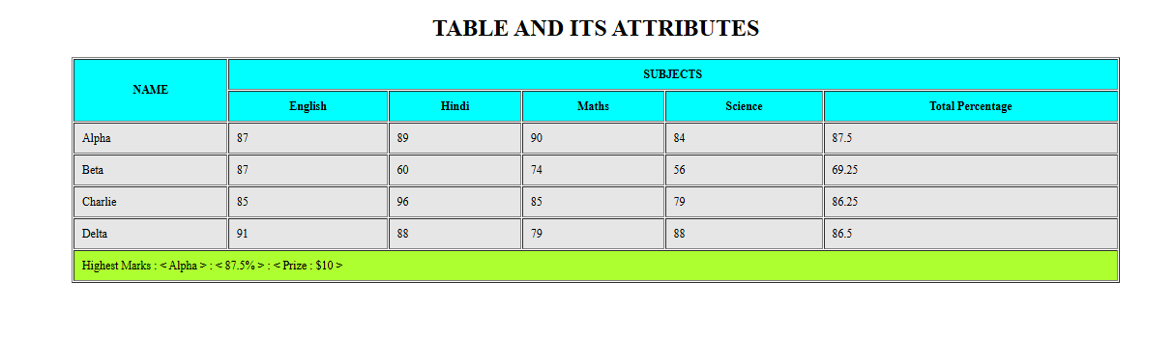

**Program 4: Create Student registration form for admission in college.**

**Index.html Page**  
<!DOCTYPE html>  
<html lang="en">  
<head>  
 <meta charset="UTF-8">  
 <meta name="viewport" content="width=device-width, initial-scale=1.0">  
 <title>MSI Student Registration Form</title>  
 <style>  
 body {  
 font-family: Arial, sans-serif;  
 background-color: #f9f9f9;  
 margin: 20px;  
 }  
 fieldset {  
 margin-bottom: 20px;  
 padding: 10px;  
 border-radius: 5px;  
 border: 1px solid #ccc;  
 }  
 legend {  
 font-weight: bold;  
 }  
 input[type="text"], input[type="email"], input[type="date"], select {  
 width: 100%;  
 padding: 8px;  
 margin-top: 5px;  
 margin-bottom: 10px;  
 border-radius: 4px;  
 border: 1px solid #ccc;  
 }  
 input[type="radio"] {  
 margin-left: 10px;  
 }  
 </style>  
</head>  
<body>  
 <h1 align="center">MSI STUDENT REGISTRATION FORM</h1>  
 <form>  
 <fieldset>  
 <legend>Personal Details</legend>  
 First Name : <input type="text" required><br>  
 Middle Name : <input type="text"><br>  
 Last Name : <input type="text"><br><br>  
 Mobile No. : <input type="text" required><br>  
 Course :   
 <select required>  
 <option disabled selected>Choose course</option>  
 <option value="BBA">BBA</option>  
 <option value="BCA">BCA</option>  
 <option value="B.Tech">B.Tech</option>  
 <option value="MBA">MBA</option>  
 </select><br><br>  
 Email : <input type="email" required><br><br>  
 D.O.B : <input type="date" required><br><br>  
 Gender :   
 <input type="radio" name="gen" value="Male"> Male   
 <input type="radio" name="gen" value="Female"> Female   
 <input type="radio" name="gen" value="Others"> Others  
 </fieldset>  
  
 <fieldset>  
 <legend>Address</legend>  
 Street Address : <input type="text" required><br>  
 City : <input type="text" required><br>  
 State : <input type="text" required><br>  
 Zip Code : <input type="text" required><br>  
 </fieldset>  
  
 <fieldset>  
 <legend>Academic Details</legend>  
 High School Name : <input type="text" required><br>  
 Year of Passing (High School) : <input type="date" required><br>  
 Undergraduate Institution (if applicable) : <input type="text"><br>  
 Year of Passing (Undergraduate) : <input type="date"><br>  
 </fieldset>  
  
 <div align="center">  
 <button type="submit">Submit</button>  
 </div>  
 </form>  
</body>  
</html>

**Output**

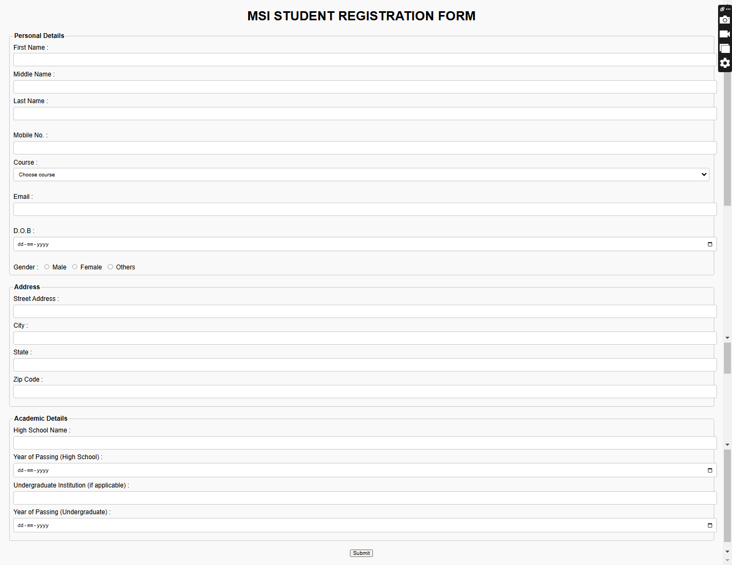

**Program 5:** **Create a web page showing India&#39;s map and create hotspots on five different states and link them to the  e-Government sites of the respective states.**

**Index.html Page**  
<!DOCTYPE html>  
<html lang="en">  
<head>  
 <meta charset="UTF-8">  
 <meta name="viewport" content="width=device-width, initial-scale=1.0">  
 <title>India</title>  
 <style>  
 img {  
 border: 2px solid black;  
 box-shadow: 0px 5px 15px black;  
 }  
 </style>  
</head>  
<body bgcolor="#E6E6E6">  
 <h1 align="center">INDIA - The Unique Charms of India's States</h1>  
 <center>  
 <caption align="bottom">MAP OF INDIA - HOTSPOTS ON jammu-kashmir, punjab, haryana, uttrakhand, himachal pradesh  
 </caption><img src="india.jpg" alt="" width="" usemap="#name">  
 </center>  
 <map name="name">  
 <area shape="poly" coords="218,77,314,60,340,40,388,138,302,118,277,148,218,77"  
 href="https://jk.gov.in/jammukashmir/" alt="jammu-kashmir">  
 <area shape="poly" coords="276,148,224,230,257,231,295,240,320,198,276,148" href="https://punjab.gov.in/"  
 alt="punjab">  
 <area shape="poly" coords="342,214,350,192,383,188,359,139,300,117,279,148,342,214"  
 href="https://himachal.nic.in/en-IN/" alt="HP">  
 <area shape="poly" coords="342,214,351,191,410,191,444,225,423,271,395,273,342,214"  
 href="https://www.india.gov.in/website-uttarakhand-government-0" alt="UTT">  
 <area shape="poly"  
 coords="342,214,322,197,296,226,295,240,245,233,243,258,275,261,275,282,295,298,319,300,334,288,316,287,325,231,342,214"  
 href="https://haryana.gov.in/" alt="HR">  
 </map>  
</body>  
</html>

**Output**

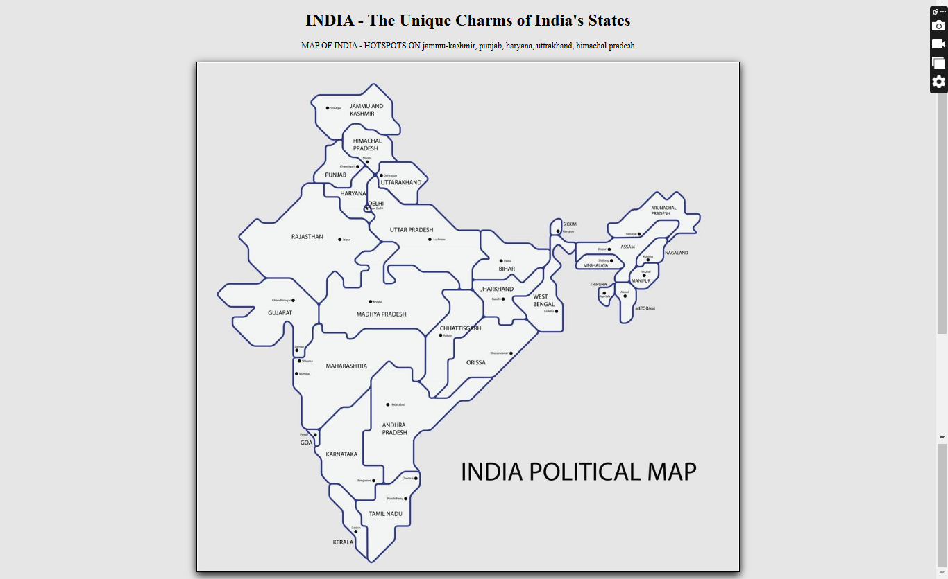

**Program 6:** **Create a web page using four frames and link them to an image, web page audio and video.**

**Index.html Page**  
<!DOCTYPE html>  
<html lang="en">  
<head>  
 <meta charset="UTF-8">  
 <meta name="viewport" content="width=device-width, initial-scale=1.0">  
 <title>four frame</title>  
</head>  
 <frameset cols="25%, 25%, 25%, 25%">  
 <frame src="image.html" name="imageFrame" title="Image Frame">  
 <frame src="wap4.html" name="webpageFrame" title="Web Page Frame">  
 <frame src="audio.html" name="audioFrame" title="Audio Frame">  
 <frame src="video.html" name="videoFrame" title="Video Frame">  
 </frameset>  
</html>

**Image.html page**

<!DOCTYPE html>

<html lang="en">

<head>

<meta charset="UTF-8">

<meta name="viewport" content="width=device-width, initial-scale=1.0">

<title>Image</title>

</head>

<body>

<h1>This is a page that contains an image</h1>

<img src="india.jpg" alt="" width="100%">

</body>

</html>

**Audio.html page**

<!DOCTYPE html>

<html lang="en">

<head>

<meta charset="UTF-8">

<meta name="viewport" content="width=device-width, initial-scale=1.0">

<title>Audio</title>

</head>

<body>

<h1>This is a page that contains an audio file.</h1>

<audio src="audio.mp3" controls loop autoplay></audio>

</body>

</html>

**Video.html page**

<!DOCTYPE html>

<html lang="en">

<head>

<meta charset="UTF-8">

<meta name="viewport" content="width=device-width, initial-scale=1.0">

<title>Video</title>

</head>

<body>

<h1>This is a page that contains a video file</h1>

<video src="video.mp4" width="100%" controls loop autoplay></video>

</body>

</html>

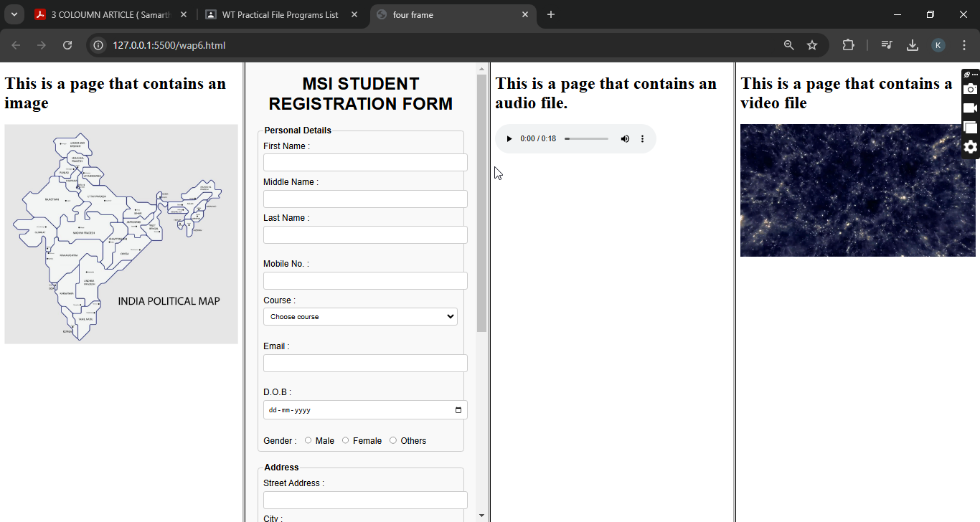**OUTPUT :**

**Program 7:** **Create an Iframe and write some lines before and after it.**

**Index.html Page**  
<!DOCTYPE html>  
<html lang="en">  
<head>  
 <meta charset="UTF-8">  
 <meta name="viewport" content="width=device-width, initial-scale=1.0">  
 <title>Iframe</title>  
</head>  
<body>  
 <h1 align="center">This page contains an iframe.</h1>  
 <p>Lorem, ipsum dolor sit amet consectetur adipisicing elit. Totam ut unde error amet laborum eum ex reiciendis eveniet iusto. Voluptatem tempore, illum sapiente sequi expedita incidunt quae dignissimos repellendus quod iusto unde quidem, quia distinctio aspernatur dolorem consequuntur. Explicabo aliquam esse fuga iusto veniam sint?</p>  
 <iframe src="https://cdn.pixabay.com/video/2021/04/19/71569-538974129_tiny.mp4" frameborder="4" allowfullscreen width="100%" height="400px"></iframe>  
 <p>Lorem ipsum dolor sit amet consectetur adipisicing elit. Nam cupiditate dolorem ullam saepe quaerat impedit, nobis repellat placeat cumque et illum omnis! Delectus, nesciunt enim. Quia explicabo modi numquam soluta iure exercitationem aut porro dolorem magni velit? Dolores minima, perspiciatis rerum ad doloremque modi aut.</p>  
</body>  
</html>

**OUTPUT :**

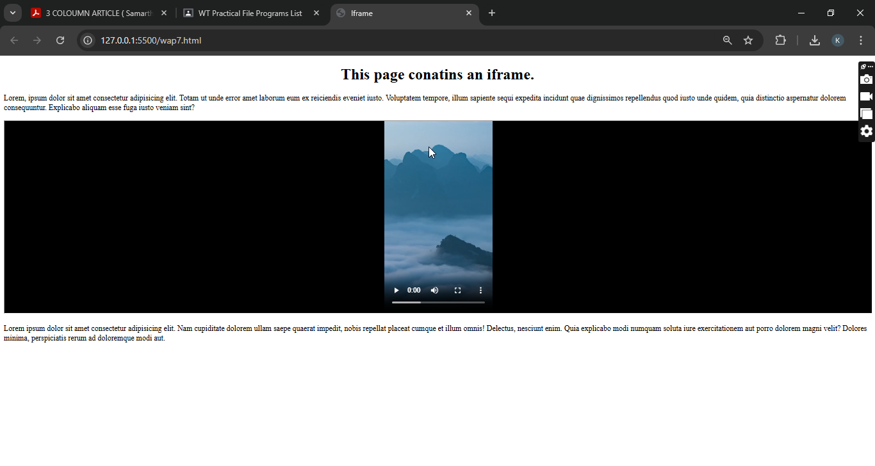

**Program 8:** **Create 3 similar webpage with inline and internal style sheet and external style sheet and apply all Text styling attributes.**

**Page1.html Page**  
<!DOCTYPE html>  
<html lang="en">  
<head>  
 <meta charset="UTF-8">  
 <meta name="viewport" content="width=device-width, initial-scale=1.0">  
 <title>Inline</title>  
</head>  
<body style="background-color: lightblue;">  
 <h1 style="color: darkblue; text-align: center; font-size: 36px;">Welcome to Inline CSS</h1>  
 <p style="color: green; font-size: 20px; font-style: italic;">This paragraph is styled using inline CSS.</p>  
</body>  
</html>

**Output**

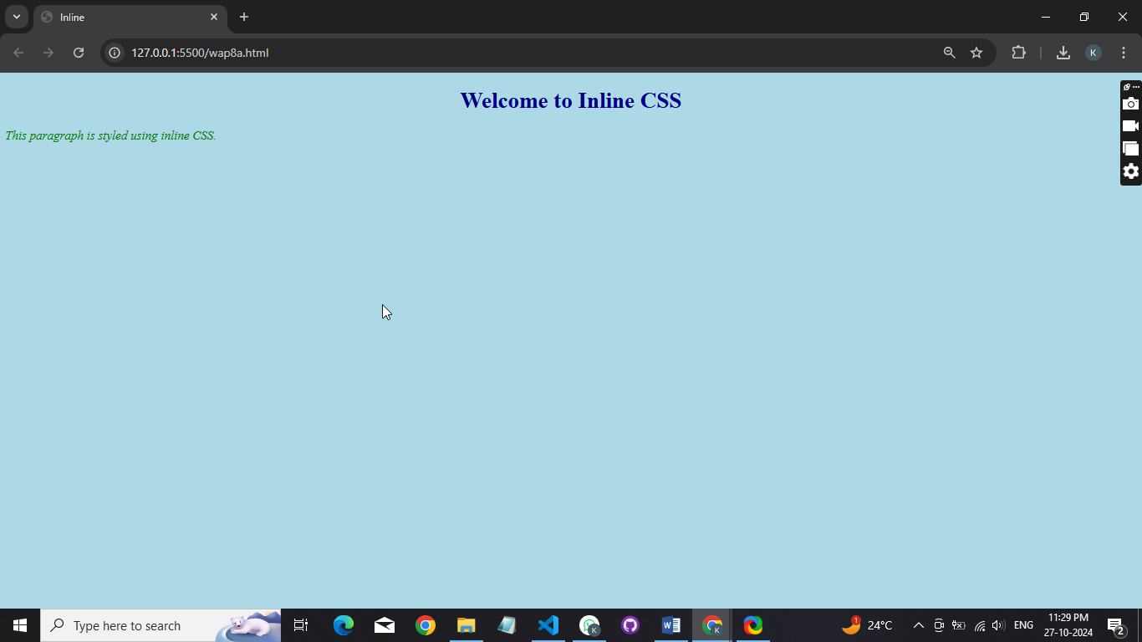

**Page2.html Page**  
<!DOCTYPE html>  
<html lang="en">  
<head>  
 <meta charset="UTF-8">  
 <meta name="viewport" content="width=device-width, initial-scale=1.0">  
 <title>Internal</title>  
 <style type="text/css">  
 body {  
 background-color: lightyellow;  
 }  
 h1 {  
 color: maroon;  
 text-align: center;  
 font-size: 36px;  
 }  
 p {  
 color: purple;  
 font-size: 20px;  
 font-weight: bold;  
 }  
 </style>  
</head>  
<body>  
 <h1>Welcome to Internal CSS</h1>  
 <p>This paragraph is styled using internal CSS.</p>  
</body>  
</html>  
**Output**

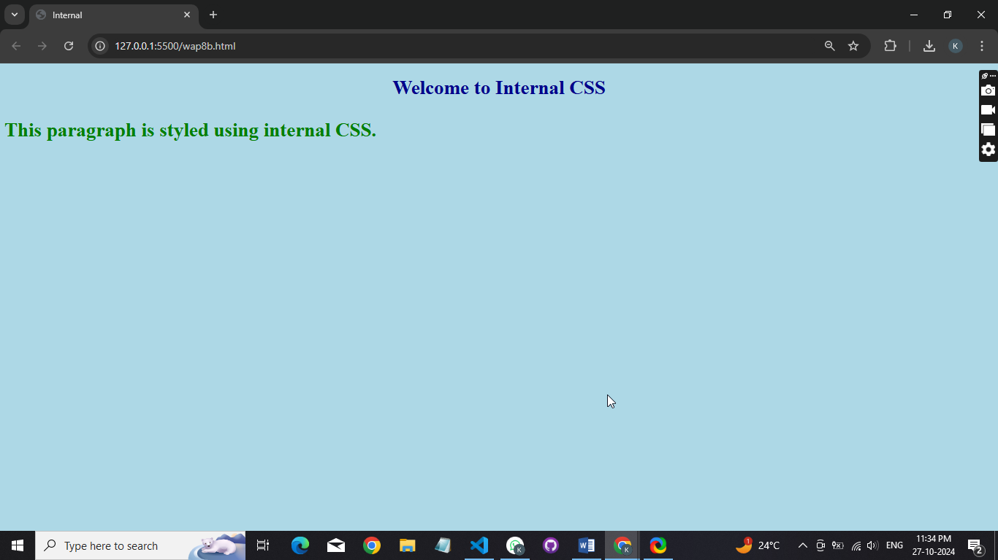

**Page3.html Page**  
<!DOCTYPE html>  
<html lang="en">  
<head>  
 <meta charset="UTF-8">  
 <meta name="viewport" content="width=device-width, initial-scale=1.0">  
 <title>External</title>  
 <link rel="stylesheet" href="style.css">  
</head>  
<body>  
 <h1>Welcome to External CSS</h1>  
 <p>This paragraph is styled using external CSS.</p>  
</body>  
</html>

**Style.css Page**

body {

background-color: lightblue;

}

h1 {

color: darkblue;

text-align: center;

font-size: 36px;

}

p {

color: green;

font-size: 36px;

text-decoration:;

}

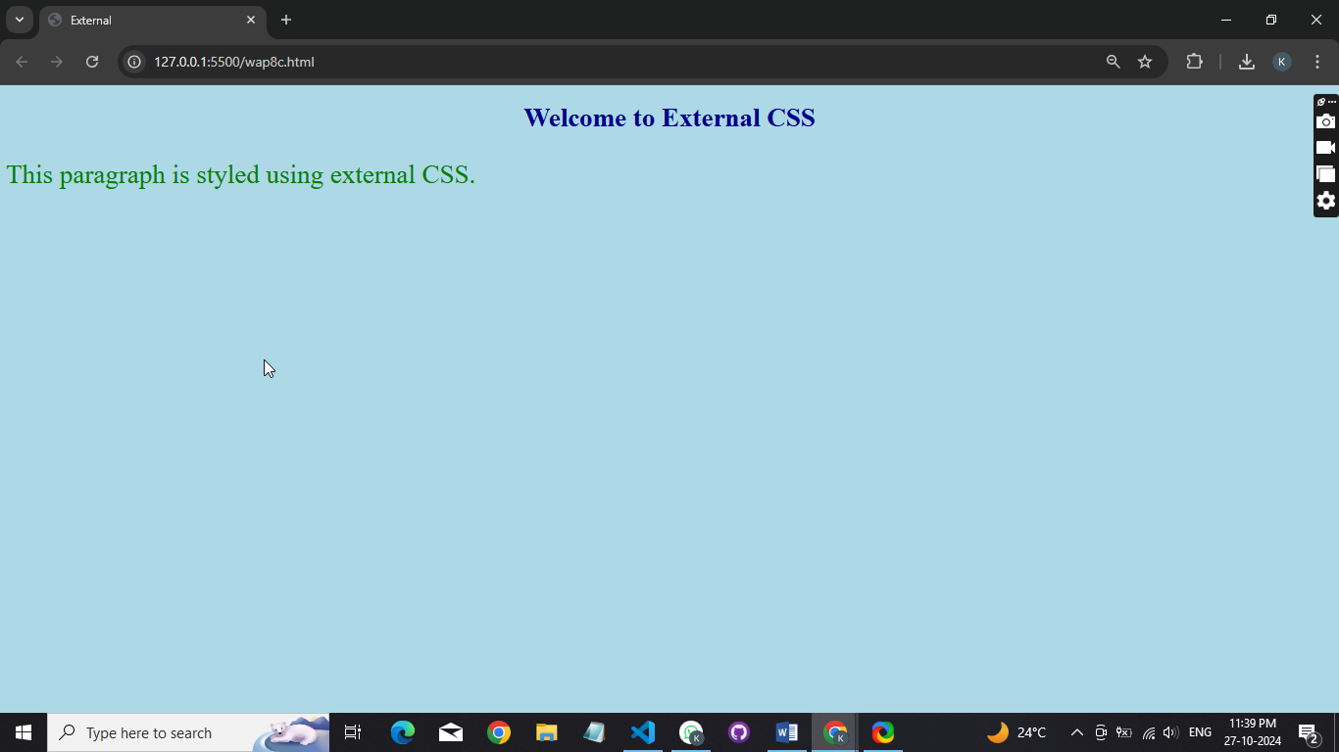**Output**

**Program 9:** **Make a Web page that uses all the following pseudo classes. Hover, active, focus, visited.**

**Index.html Page**

<!DOCTYPE html>  
<html lang="en">  
<head>  
 <meta charset="UTF-8">  
 <meta name="viewport" content="width=device-width, initial-scale=1.0">  
 <title>Pseudo-Classes Example</title>  
 <link href="https://cdn.jsdelivr.net/npm/bootstrap@5.0.2/dist/css/bootstrap.min.css" rel="stylesheet">  
 <style>  
 /* Link styles */  
 a {  
 color: blue;  
 text-decoration: none;  
 }  
 a:visited {  
 color: purple; /* Color for visited links */  
 }  
 a:hover {  
 color: red; /* Color when hovered */  
 text-decoration: underline; /* Underline on hover */  
 }  
 a:active {  
 color: green; /* Color when active (clicked) */  
 }  
 /* Button styles */  
 .btn-custom {  
 background-color: lightgray;  
 border: 1px solid #ccc;  
 }  
 .btn-custom:hover {  
 background-color: darkgray; /* Change on hover */  
 }  
 .btn-custom:focus {  
 outline: 2px solid blue; /* Outline on focus */  
 }  
 </style>  
</head>  
<body>  
<div class="container mt-5">  
 <h1 class="text-center">CSS Pseudo-Classes Example</h1>  
 <div class="text-center mt-4">  
 <h2>Links</h2>  
 <p>  
 <a href="https://www.example.com" target="_blank">Visit Example.com</a>  
 </p>  
 </div>  
 <div class="text-center mt-4">  
 <h2>Buttons</h2>  
 <button class="btn btn-custom" onclick="alert('Button clicked!')">Click Me!</button>  
 </div>  
 <div class="text-center mt-4">  
 <h2>Focus Example</h2>  
 <input type="text" placeholder="Focus on me!" class="form-control" style="width: 300px; margin: auto;">  
 </div>  
</div>  
</body>  
</html>

**Output**

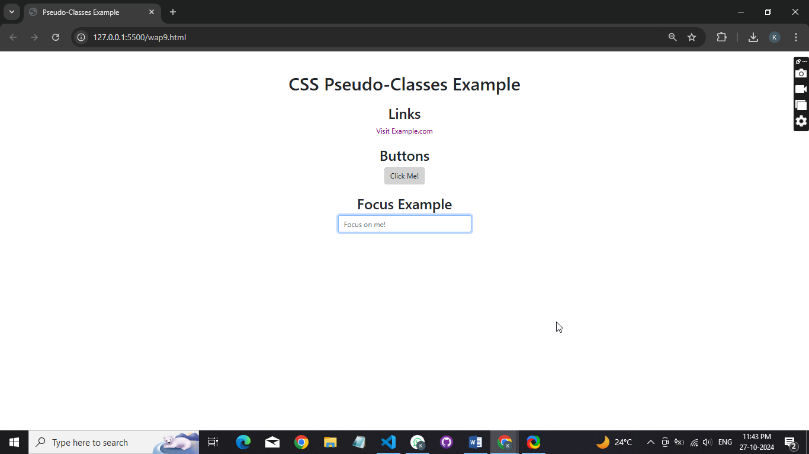**Program 10:** **Create a web page that use Id and class selector.**

**Index.html Page**

<!DOCTYPE html>  
<html lang="en">  
<head>  
 <meta charset="UTF-8">  
 <meta name="viewport" content="width=device-width, initial-scale=1.0">  
 <title>ID and Class Selector Example</title>  
 <link href="https://cdn.jsdelivr.net/npm/bootstrap@5.0.2/dist/css/bootstrap.min.css" rel="stylesheet">  
 <style>  
 /* ID Selector */  
 #header {  
 background-color: lightblue;  
 padding: 20px;  
 text-align: center;  
 border: 2px solid blue;  
 }  
 /* Class Selector */  
 .highlight {  
 background-color: yellow;  
 font-weight: bold;  
 }  
 .text-center {  
 text-align: center;  
 }  
 </style>  
</head>  
<body>  
<div id="header">  
 <h1>Welcome to My Web Page</h1>  
</div>  
<div class="container mt-4">  
 <h2 class="text-center">Using ID and Class Selectors</h2>  
 <p>This paragraph is styled using a class selector. It has a <span class="highlight">highlighted text</span> to demonstrate the class styling.</p>  
 <p>This is another paragraph without additional styling.</p>  
 <p id="uniqueParagraph">This paragraph is styled using an ID selector. It has a unique background color.</p>  
</div>  
<script src="https://cdn.jsdelivr.net/npm/bootstrap@5.0.2/dist/js/bootstrap.bundle.min.js"></script>  
</body>  
</html>

**Output**

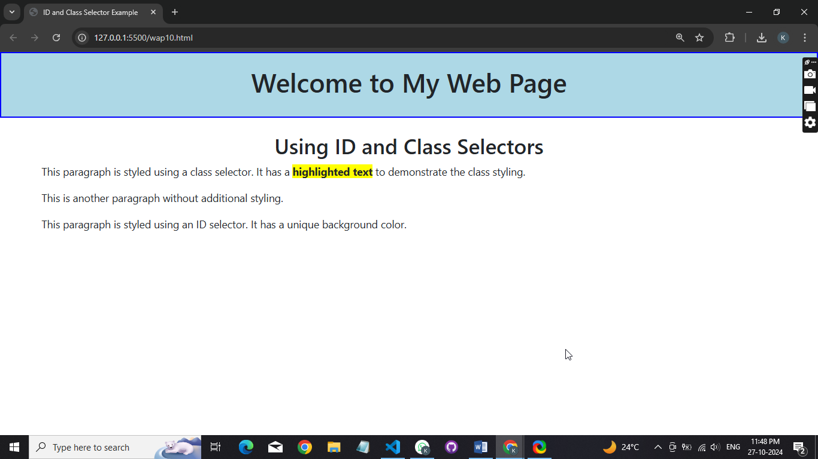

**Program 11:** **Create separate web pages containing: Container Class, Grid, Tables, Image, Button, Typography, Jumbotron, Glyphicons.**

**Container class**

<!DOCTYPE html>  
<html lang="en">  
<head>  
 <meta charset="UTF-8">  
 <meta name="viewport" content="width=device-width, initial-scale=1.0">  
 <title>Container Class Example</title>  
 <link href="https://cdn.jsdelivr.net/npm/bootstrap@5.0.2/dist/css/bootstrap.min.css" rel="stylesheet">  
</head>  
<body>  
  
<div class="container">  
 <h1 class="text-center">Container Class</h1>  
 <p>This is an example of a container class in Bootstrap.</p>  
</div>  
  
<script src="https://cdn.jsdelivr.net/npm/bootstrap@5.0.2/dist/js/bootstrap.bundle.min.js"> </script>  
</body>  
</html>

**Output**

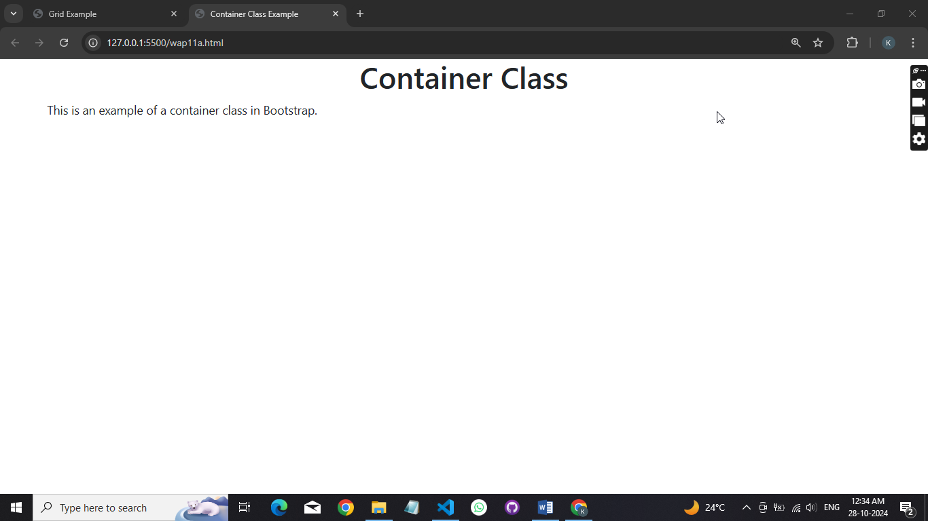

**Grid**  
<!DOCTYPE html>  
<html lang="en">  
<head>  
 <meta charset="UTF-8">  
 <meta name="viewport" content="width=device-width, initial-scale=1.0">  
 <title>Grid Example</title>  
 <link href="https://cdn.jsdelivr.net/npm/bootstrap@5.0.2/dist/css/bootstrap.min.css" rel="stylesheet">  
</head>  
<body>  
  
<h1 class="text-center">Grid Example</h1>  
  
<div class="container">  
 <div class="row">  
 <div class="col">Column 1</div>  
 <div class="col">Column 2</div>  
 <div class="col">Column 3</div>  
 </div>  
</div>  
  
<script src="https://cdn.jsdelivr.net/npm/bootstrap@5.0.2/dist/js/bootstrap.bundle.min.js"> </script>  
</body>  
</html>

**Output**  
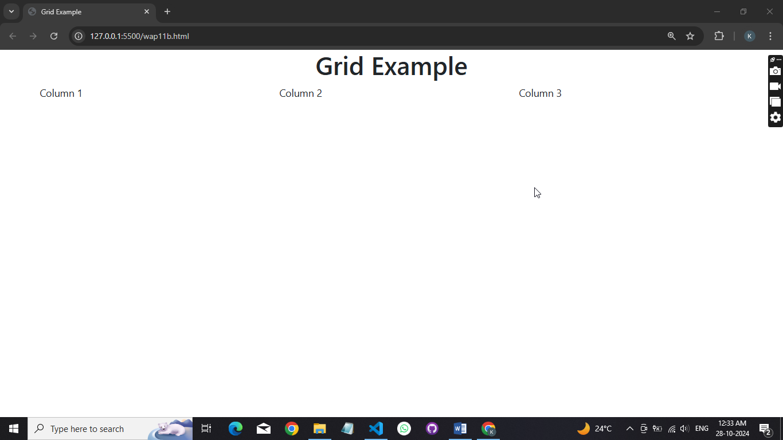

**Table**  
<!DOCTYPE html>

<html lang="en">

<head>

<meta charset="UTF-8">

<meta name="viewport" content="width=device-width, initial-scale=1.0">

<title>Table Example</title>

<link href="https://cdn.jsdelivr.net/npm/bootstrap@5.0.2/dist/css/bootstrap.min.css" rel="stylesheet">

</head>

<body>

<h1 class="text-center">Table Example</h1>

<div class="container">

<table class="table table-bordered">

<thead>

<tr>

<th>Name</th>

<th>Age</th>

<th>City</th>

</tr>

</thead>

<tbody>

<tr>

<td>John Doe</td>

<td>30</td>

<td>New York</td>

</tr>

<tr>

<td>Jane Smith</td>

<td>25</td>

<td>Los Angeles</td>

</tr>

</tbody>

</table>

</div>

<script src="https://cdn.jsdelivr.net/npm/bootstrap@5.0.2/dist/js/bootstrap.bundle.min.js"></script>

</body>

</html>

**Output**

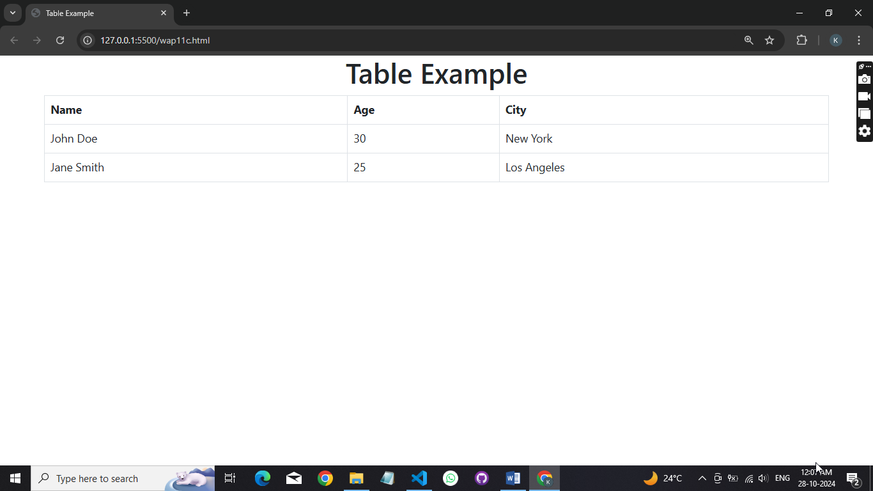

**Image**

<!DOCTYPE html>

<html lang="en">

<head>

<meta charset="UTF-8">

<meta name="viewport" content="width=device-width, initial-scale=1.0">

<title>Image Example</title>

<link href="https://cdn.jsdelivr.net/npm/bootstrap@5.0.2/dist/css/bootstrap.min.css" rel="stylesheet">

</head>

<body>

<h1 class="text-center">Image Example</h1>

<div class="container text-center">

<img src="https://via.placeholder.com/300" alt="Placeholder Image" class="img-fluid">

<p>This is an example of an image in Bootstrap.</p>

</div>

<script src="https://cdn.jsdelivr.net/npm/bootstrap@5.0.2/dist/js/bootstrap.bundle.min.js"> </script>

</body>

</html>

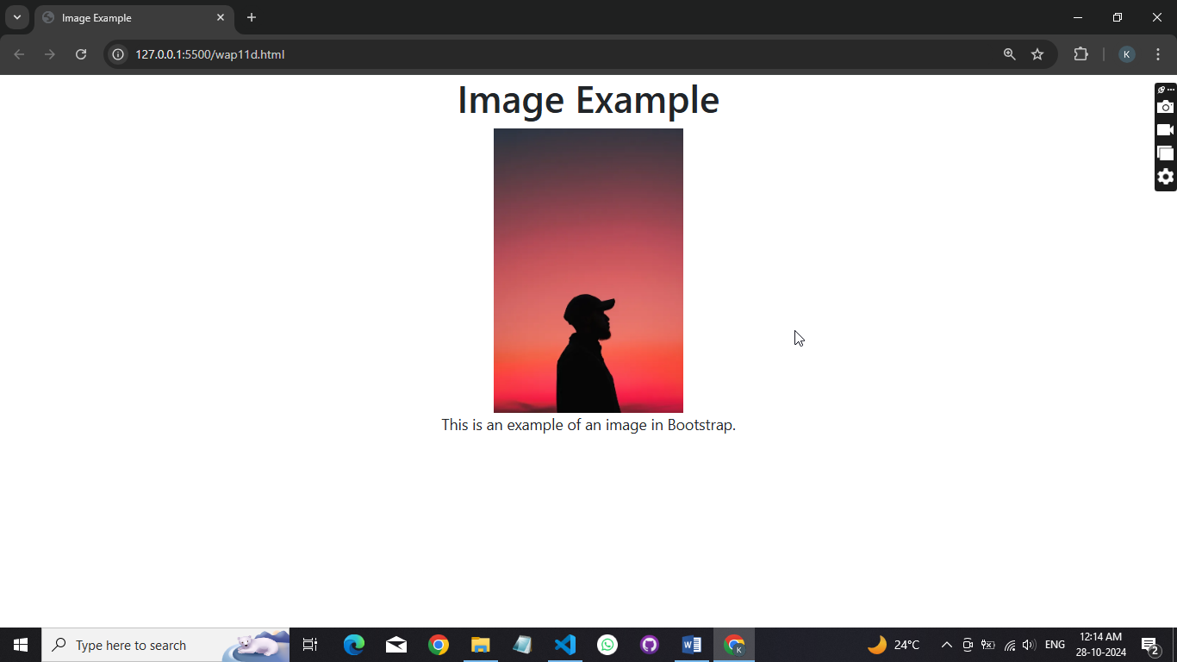**Output**

**Button**

<!DOCTYPE html>

<html lang="en">

<head>

<meta charset="UTF-8">

<meta name="viewport" content="width=device-width, initial-scale=1.0">

<title>Button Example</title>

<link href="https://cdn.jsdelivr.net/npm/bootstrap@5.0.2/dist/css/bootstrap.min.css" rel="stylesheet">

</head>

<body>

<h1 class="text-center">Button Example</h1>

<div class="container text-center">

<button class="btn btn-primary" onclick="alert('Button clicked!')">Click Me!</button>

<p>This button triggers an alert when clicked.</p>

</div>

<script src="https://cdn.jsdelivr.net/npm/bootstrap@5.0.2/dist/js/bootstrap.bundle.min.js"></script>

</body>

</html>

**Output**

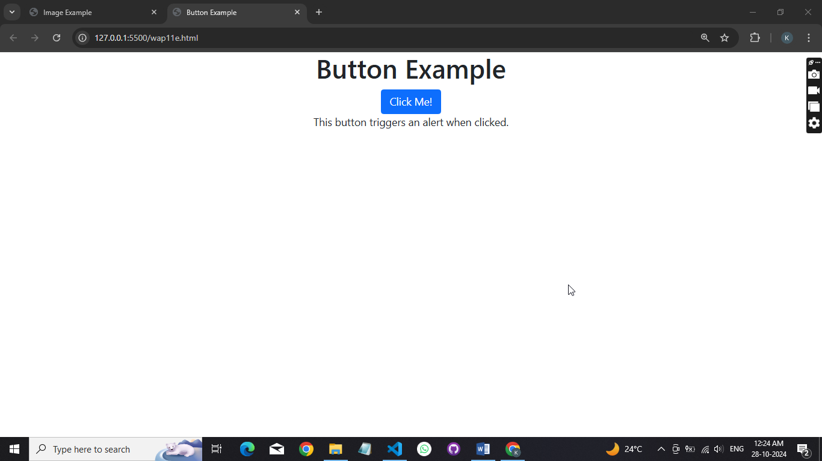

**Typography**

<!DOCTYPE html>

<html lang="en">

<head>

<meta charset="UTF-8">

<meta name="viewport" content="width=device-width, initial-scale=1.0">

<title>Typography Example</title>

<link href="https://cdn.jsdelivr.net/npm/bootstrap@5.0.2/dist/css/bootstrap.min.css" rel="stylesheet">

</head>

<body>

<h1 class="text-center">Typography Example</h1>

<div class="container text-center">

<p>This is an example of typography in Bootstrap.</p><br/>

<p class='fw-bold'>Bold text with Bootstrap styling.</p><br/>

<p class='text-danger'>This is a danger text.</p><br/>

</div>

<script src="https://cdn.jsdelivr.net/npm/bootstrap@5.0.2/dist/js/bootstrap.bundle.min.js"></script>

</body>

</html>

**Output**

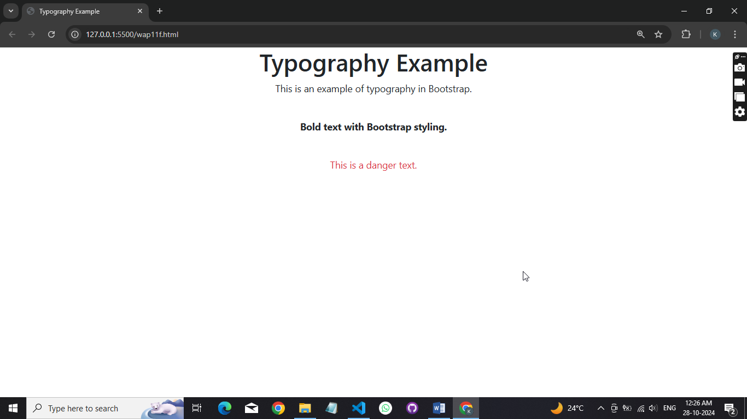

**Jumbotron**

<!DOCTYPE html>

<html lang="en">

<head>

<meta charset="UTF-8">

<meta name="viewport" content="width=device-width, initial-scale=1.0">

<title>Jumbotron Example</title>

<link href="https://cdn.jsdelivr.net/npm/bootstrap@5.0.2/dist/css/bootstrap.min.css" rel="stylesheet">

</head>

<body>

<div class="jumbotron text-center bg-light p-4 mb-4 rounded-3">

<h1 class='display-4'>Welcome to My Website!</h1><br/>

<p>This is a simple jumbotron example using Bootstrap.</p><br/>

</div>

<script src='https://cdn.jsdelivr.net/npm/bootstrap@5.0.2/dist/js/bootstrap.bundle.min.js'> </script>

</body>

</html>

**Output**

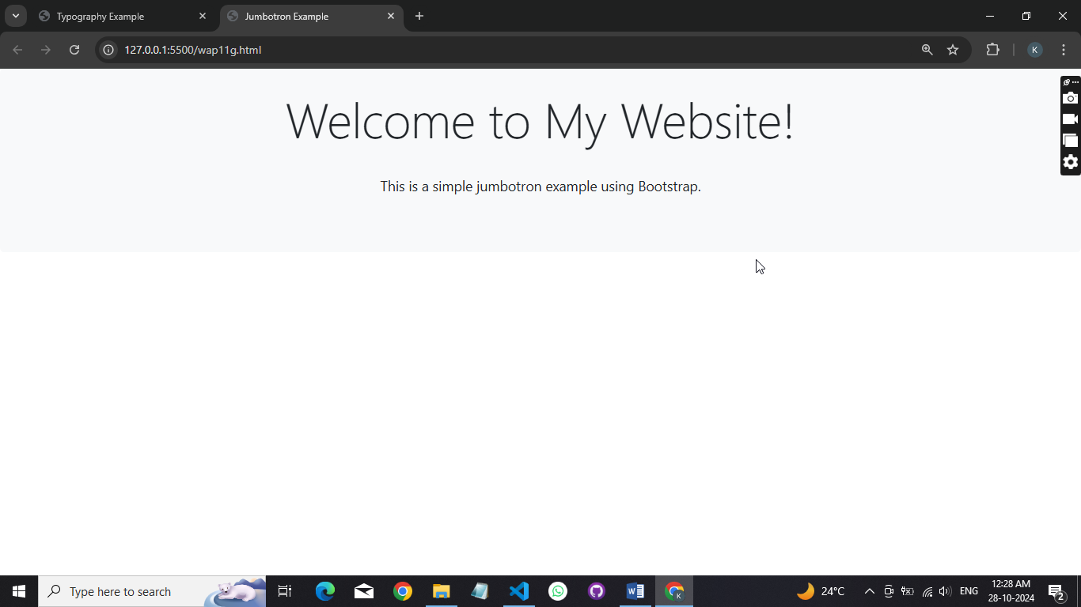

**Glyphicons**

<!DOCTYPE html>

<html lang='en'>

<head>

<meta charset='utf-8'>

<meta name='viewport' content='width=device-width, initial-scale=1'>

<title>Glyphicons Example with Font Awesome</title>

<link href='https://cdnjs.cloudflare.com/ajax/libs/font-awesome/6.0.0-beta3/css/all.min.css' rel='stylesheet'>

<link href='https://cdn.jsdelivr.net/npm/bootstrap@5.0.2/dist/css/bootstrap.min.css' rel='stylesheet'>

<style>

.icon { font-size: 24px; margin-right: 10px; }

</style></head><body>

<h1 class='text-center'>Glyphicons Example with Font Awesome!</h1><br/>

<div class='container text-center'>

<span class='icon'><i class='fas fa-star'></i></span> Star Icon<br/>

<span class='icon'><i class='fas fa-heart'></i></span> Heart Icon<br/>

<span class='icon'><i class='fas fa-check'></i></span> Checkmark Icon<br/>

</div><script src='https://cdn.jsdelivr.net/npm/bootstrap@5.0.2/dist/js/bootstrap.bundle.min.js'></script>

</body>

</html>

**Output**

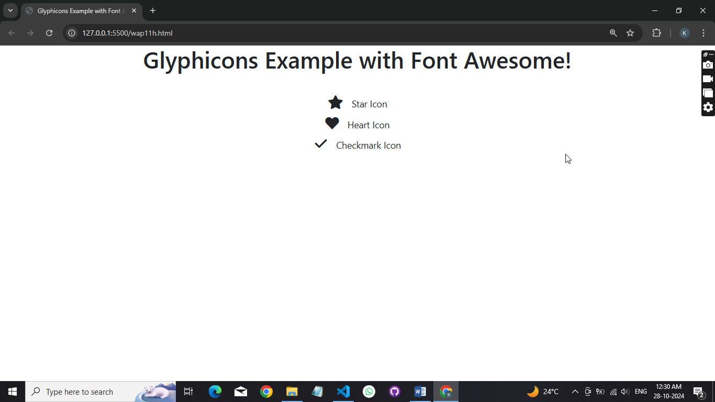

**Program 12:** **WAP to make use of JavaScript Operator.**

**Code :**

let a = 15;

let b = 5;

// Arithmetic Operations

console.log("Arithmetic Operations:");

console.log("Addition:", a + b);

console.log("Subtraction:", a - b);

console.log("Multiplication:", a * b);

console.log("Division:", a / b);

console.log("Modulus:", a % b);

console.log("Exponentiation:", a ** b);

// Assignment Operations

console.log("\nAssignment Operations:");

let c = a;

console.log("c =", c);

a += b;

console.log("a += b:", a);

a -= b;

console.log("a -= b:", a);

a *= b;

console.log("a *= b:", a);

a /= b;

console.log("a /= b:", a);

// Comparison Operations

console.log("\nComparison Operations:");

console.log("a == b:", a == b);

console.log("a != b:", a != b);

console.log("a > b:", a > b);

console.log("a < b:", a < b);

console.log("a >= b:", a >= b);

console.log("a <= b:", a <= b);

// Logical Operations

console.log("\nLogical Operations:");

console.log("a > 10 && b < 10:", a > 10 && b < 10);

console.log("a > 10 || b > 10:", a > 10 || b > 10);

console.log("!(a > b):", !(a > b));

// Conditional (Ternary) Operator

let result = a > b ? "a is greater" : "b is greater";

console.log("\nConditional Operator:", result);

// Type Operations

console.log("\nType Operations:");

console.log("Type of a:", typeof a);

console.log("Is a a number?", typeof a === 'number');

// Bitwise Operations

console.log("\nBitwise Operations:");

console.log("a & b:", a & b);

console.log("a | b:", a | b);

console.log("a ^ b:", a ^ b);

console.log("a << 1:", a << 1);

console.log("a >> 1:", a >> 1);

**Output :**

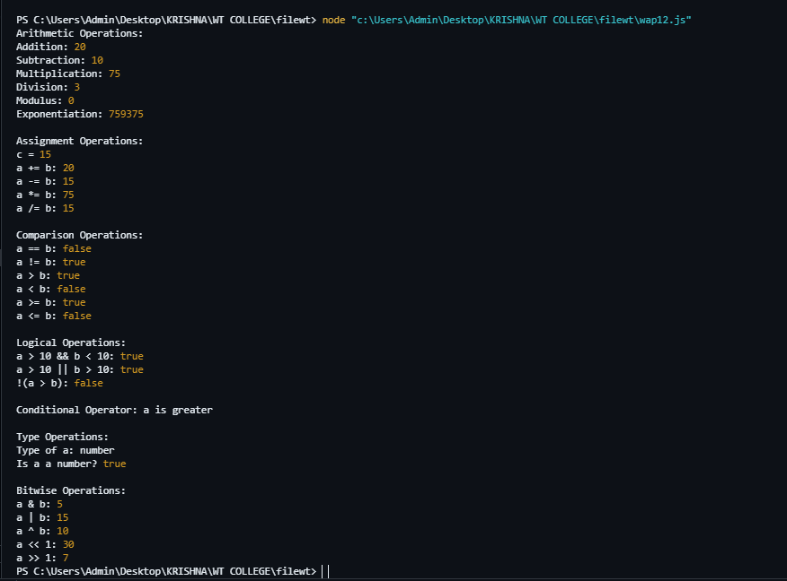

**Program 13:** **WAP to make use of statements : if , else, else if, switch, while, do while, for, for in , for of.**

**Code :**

let number = 5;

let fruits = ['apple', 'banana', 'cherry'];

let person = { name: 'Alice', age: 25 };

// Using if, else if, and else

if (number > 10) {

console.log('Number is greater than 10');

} else if (number === 10) {

console.log('Number is equal to 10');

} else {

console.log('Number is less than 10');

}

// Using switch

let fruit = 'banana';

switch (fruit) {

case 'apple':

console.log('This is an apple');

break;

case 'banana':

console.log('This is a banana');

break;

case 'cherry':

console.log('This is a cherry');

break;

default:

console.log('Unknown fruit');

}

// Using while

let count = 0;

while (count < 3) {

console.log("Count is :",count);

count++;

}

// Using do while

let index = 0;

do {

console.log("Index is :",index);

index++;

} while (index < 3);

// Using for

for (let i = 0; i < 3; i++) {

console.log("i is :",i);

}

// Using for...in

for (let key in person) {

console.log(key,person[key]);

}

// Using for...of

for (let fruit of fruits) {

console.log(fruit);

}

**Output :**

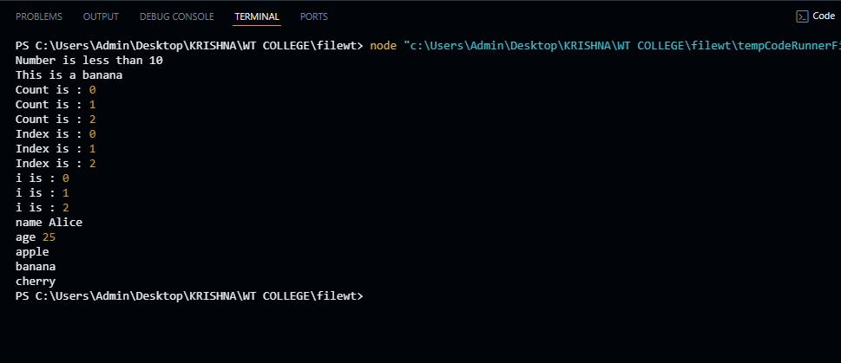

**Program 14:** **WAP to make use of following objects : date, math, string.**

**Code :**

// Using the Date object

function displayCurrentDate() {

const currentDate = new Date();

console.log("Current Date and Time: " + currentDate.toString());

}

// Using the Math object

function performMathOperations() {

const num1 = 10;

const num2 = 3;

console.log(`Math Operations on ${num1} and ${num2}:`);

console.log("Addition: " + (num1 + num2));

console.log("Subtraction: " + (num1 - num2));

console.log("Multiplication: " + (num1 * num2));

console.log("Division: " + (num1 / num2));

console.log("Power: " + Math.pow(num1, num2));

console.log("Square Root of " + num1 + ": " + Math.sqrt(num1));

console.log("Random Number: " + Math.random());

}

// Using the String object

function manipulateStrings() {

const str = " Hello, JavaScript! ";

console.log("Original String: '" + str + "'");

console.log("Trimmed String: '" + str.trim() + "'");

console.log("Uppercase: '" + str.toUpperCase() + "'");

console.log("Lowercase: '" + str.toLowerCase() + "'");

console.log("Substring (from index 2 to 5): '" + str.substring(2, 5) + "'");

console.log("String Length: " + str.length);

}

displayCurrentDate();

performMathOperations();

manipulateStrings();

**Output :**

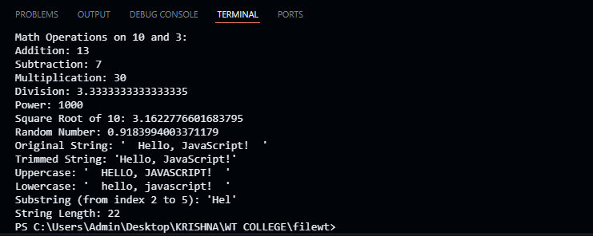

**Program 15:** **WAP to show use of object in JavaScript: By object literal, By instance of object directly, By using object constructor**

**Code :**

// 1. Using Object Literal

const personLiteral = {

name: 'Alice',

age: 30,

greet: function() {

console.log(`Hello, my name is ${this.name} and I am ${this.age} years old.`);

}

};

// 2. Creating an Instance Directly

const carInstance = {

brand: 'Toyota',

model: 'Camry',

year: 2021,

displayInfo: function() {

console.log(`Car: ${this.brand} ${this.model}, Year: ${this.year}`);

}

};

// 3. Using an Object Constructor

function Animal(type, name) {

this.type = type;

this.name = name;

this.introduce = function() {

console.log(`I am a ${this.type} named ${this.name}.`);

};

}

const dog = new Animal('Dog', 'Buddy');

// Using the objects

personLiteral.greet(); // Output: Hello, my name is Alice and I am 30 years old.

carInstance.displayInfo(); // Output: Car: Toyota Camry, Year: 2021

dog.introduce(); // Output: I am a Dog named Buddy.

**Output :**

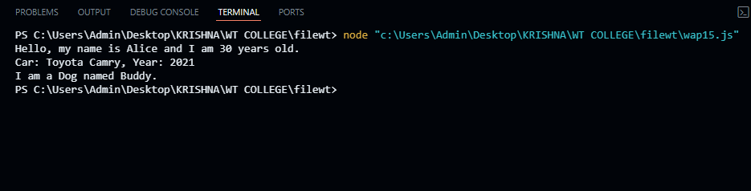

**Program 16:** **WAP to show validation in Java Script.**

**Code :**

<!DOCTYPE html>

<html lang="en">

<head>

<meta charset="UTF-8">

<meta name="viewport" content="width=device-width, initial-scale=1.0">

<title>Form Validation</title>

<style>

.error {

color: red;

}

</style>

</head>

<body>

<h1>Registration Form</h1>

<form id="registrationForm">

<label for="email">Email:</label>

<input type="text" id="email" name="email" required>

<span class="error" id="emailError"></span>

<br><br>

<label for="password">Password:</label>

<input type="password" id="password" name="password" required>

<span class="error" id="passwordError"></span>

<br><br>

<button type="submit">Submit</button>

</form>

<script src="wap16.js"></script>

</body>

</html>

**Wap16.js code :**

document.getElementById('registrationForm').addEventListener('submit', function(event) {

event.preventDefault(); // Prevent form submission

// Clear previous error messages

document.getElementById('emailError').textContent = '';

document.getElementById('passwordError').textContent = '';

// Get input values

const email = document.getElementById('email').value;

const password = document.getElementById('password').value;

let isValid = true;

// Validate email

const emailPattern = /^[^\s@]+@[^\s@]+\.[^\s@]+$/;

if (!emailPattern.test(email)) {

document.getElementById('emailError').textContent = 'Please enter a valid email address.';

isValid = false;

}

// Validate password

if (password.length < 6) {

document.getElementById('passwordError').textContent = 'Password must be at least 6 characters long.';

isValid = false;

}

// If valid, you can submit the form or perform further actions

if (isValid) {

alert('Form submitted successfully!');

// Here you can proceed with form submission, e.g., via AJAX or direct submission.

// this.submit();

}

});

**Output :**

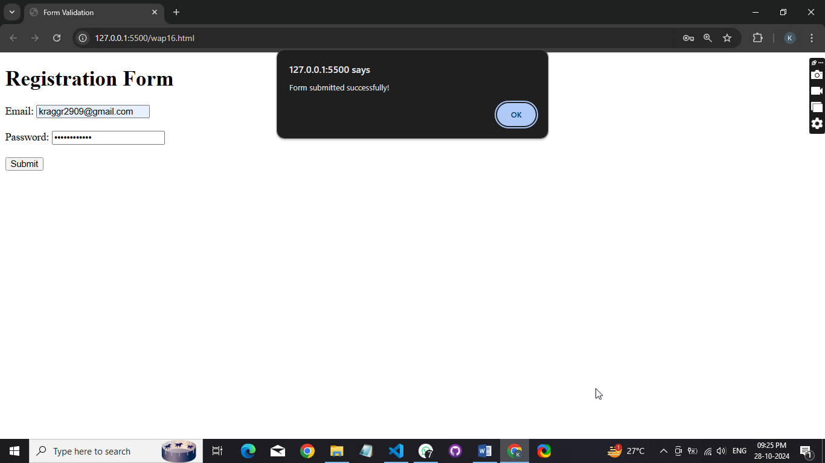

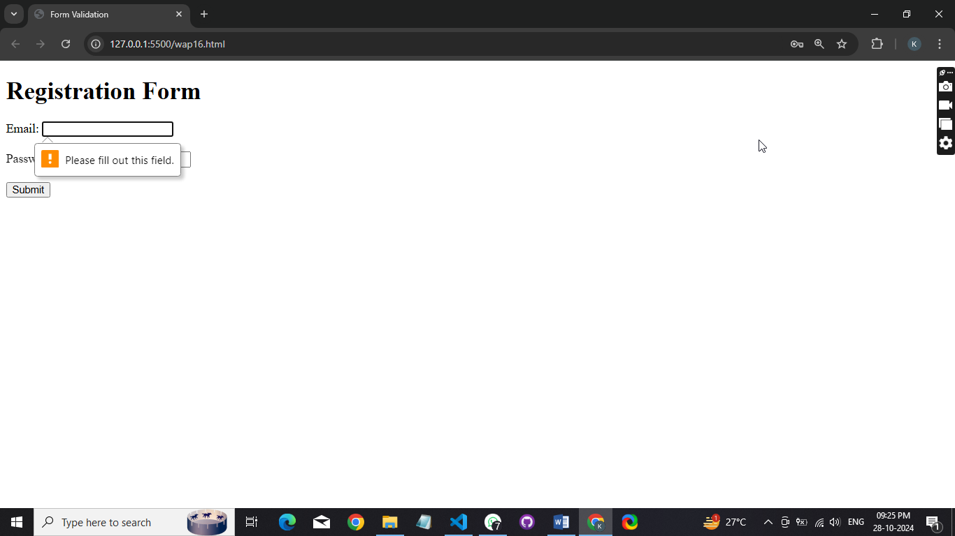

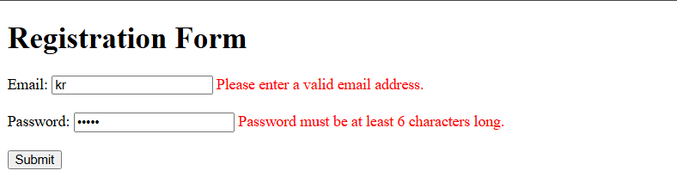

**Program 17:** **WAP to make use of in-built functions.**

**Code :**

// String Methods

const str = "hello";

console.log("Uppercase:", str.toUpperCase()); // "HELLO"

const sentence = "Hello World";

const words = sentence.split(" ");

console.log("Split words:", words); // ["Hello", "World"]

// Array Methods

const arr = [1, 2, 3];

arr.push(4);

console.log("Array after push:", arr); // [1, 2, 3, 4]

const numbers = [1, 2, 3];

const squares = numbers.map(num => num * num);

console.log("Squares:", squares); // [1, 4, 9]

// Math Methods

const max = Math.max(1, 3, 2);

console.log("Max value:", max); // 3

const randomNum = Math.random();

console.log("Random number:", randomNum); // e.g., 0.123456789

// Date Methods

const date = new Date();

console.log("Current Year:", date.getFullYear()); // e.g., 2024

console.log("ISO String:", date.toISOString()); // e.g., "2024-10-25T12:34:56.789Z"

// JSON Methods

const obj = { name: "Alice", age: 25 };

const jsonString = JSON.stringify(obj);

console.log("JSON String:", jsonString); // '{"name":"Alice","age":25}'

const parsedObj = JSON.parse(jsonString);

console.log("Parsed Object:", parsedObj); // { name: "Alice", age: 25 }

**Output :**

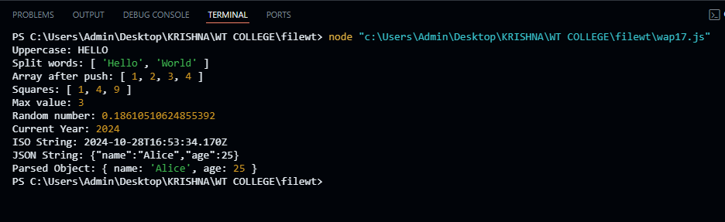

**Program 18:** **WAP to show usage of : alert box, prompt box, confirm box.**

**Code :**

<!DOCTYPE html>

<html lang="en">

<head>

<meta charset="UTF-8">

<meta name="viewport" content="width=device-width, initial-scale=1.0">

<title>Alert, Prompt, and Confirm Box Example</title>

<script type="text/javascript">

function showAlert() {

alert("This is an alert message!");

}

function showPrompt() {

var name = prompt("Please enter your name:", "John Doe");

if (name != null && name != "") {

alert("Hello " + name + "!");

} else {

alert("No name entered.");

}

}

function showConfirm() {

var result = confirm("Do you want to proceed?");

if (result) {

alert("You pressed OK!");

} else {

alert("You pressed Cancel!");

}

}

</script>

</head>

<body>

<h1>JavaScript Dialog Boxes Example</h1>

<button onclick="showAlert()">Show Alert Box</button>

<button onclick="showPrompt()">Show Prompt Box</button>

<button onclick="showConfirm()">Show Confirm Box</button>

</body>

</html>

**Output :**

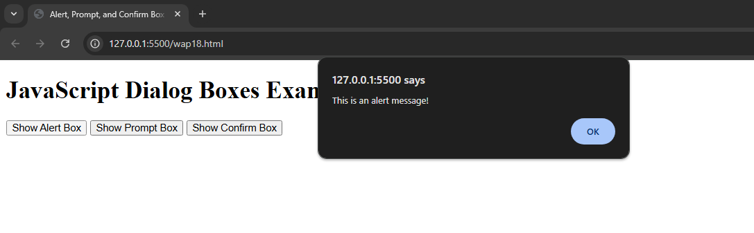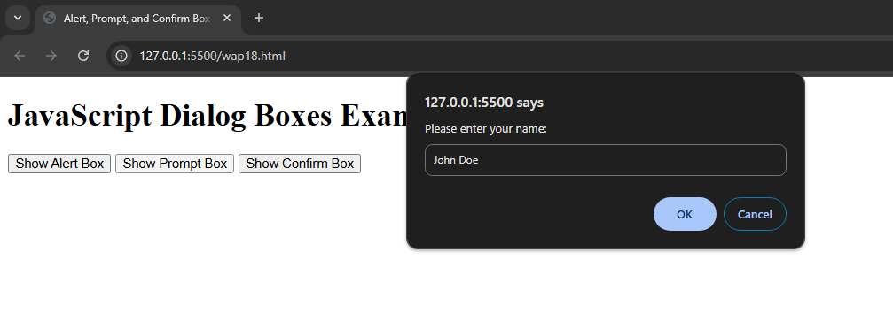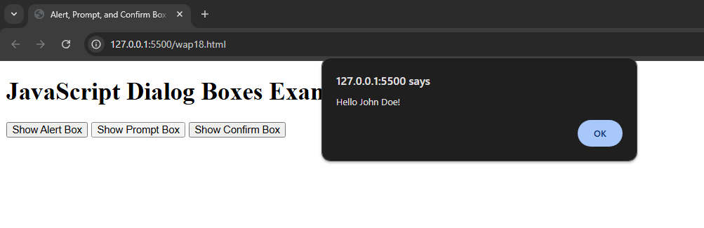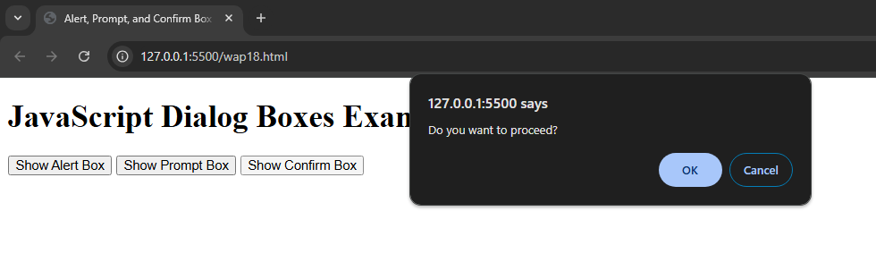

**Program 19:** **WAP demonstrating : Factorial of number, Prime number in a range, Reverse of a number.**

**Code :**

// Function to calculate factorial

function factorial(num) {

if (num < 0) {

return "Factorial is not defined for negative numbers.";

}

let result = 1;

for (let i = 1; i <= num; i++) {

result *= i;

}

return result;

}

// Function to find prime numbers in a range

function findPrimes(start, end) {

let primes = [];

for (let num = start; num <= end; num++) {

if (num > 1) {

let isPrime = true;

for (let i = 2; i <= Math.sqrt(num); i++) {

if (num % i === 0) {

isPrime = false;

break;

}

}

if (isPrime) {

primes.push(num);

}

}

}

return primes;

}

// Function to reverse a number

function reverseNumber(num) {

return num.toString().split('').reverse().join('');

}

console.log("Factorial of 5:", factorial(5));

console.log("Prime numbers between 10 and 50:", findPrimes(10, 50));

console.log("Reverse of 12345:", reverseNumber(12345));

**Output :**

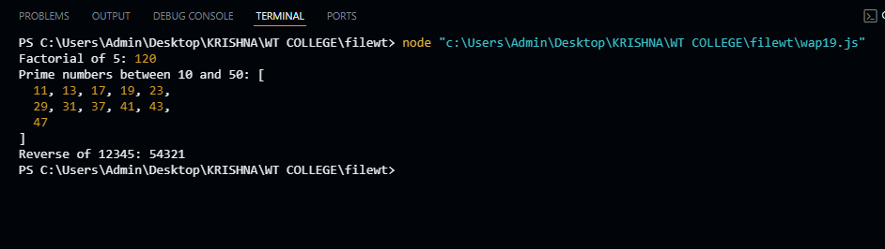

**Program 20:** **WAP to implement event handling using**

**onclick, mouseover, mouseout, mousein, doubleclick, mousemove**

**Code :**

<!DOCTYPE html>

<html lang="en">

<head>

<meta charset="UTF-8">

<meta name="viewport" content="width=device-width, initial-scale=1.0">

<title>Event Handling Example</title>

<style>

#eventBox {

width: 300px;

height: 200px;

border: 2px solid #000;

margin: 20px;

text-align: center;

line-height: 200px;

font-size: 20px;

transition: background-color 0.3s;

}

</style>

</head>

<body>

<h1>Event Handling Demonstration</h1>

<div id="eventBox">Hover or Click Me!</div>

<script>

const eventBox = document.getElementById('eventBox');

// Onclick Event

eventBox.onclick = function() {

alert('Box clicked!');

};

// Mouseover Event

eventBox.onmouseover = function() {

eventBox.style.backgroundColor = '#f0f0f0';

eventBox.innerHTML = 'Mouse Over!';

};

// Mouseout Event

eventBox.onmouseout = function() {

eventBox.style.backgroundColor = '#fff';

eventBox.innerHTML = 'Hover or Click Me!';

};

// Mouseenter Event

eventBox.onmouseenter = function() {

console.log('Mouse entered the box.');

};

// Double Click Event

eventBox.ondblclick = function() {

alert('Box double-clicked!');

};

// Mousemove Event

eventBox.onmousemove = function(event) {

const x = event.clientX - eventBox.getBoundingClientRect().left;

const y = event.clientY - eventBox.getBoundingClientRect().top;

console.log(`Mouse position: X: ${x}, Y: ${y}`);

};

</script>

</body>

</html>

**Output :**

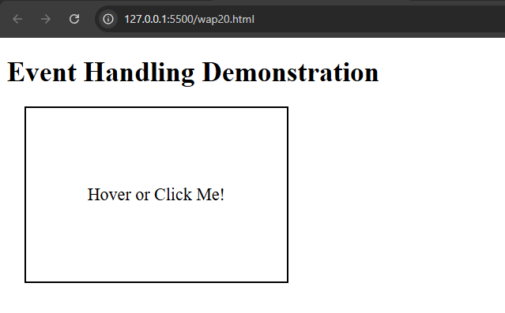

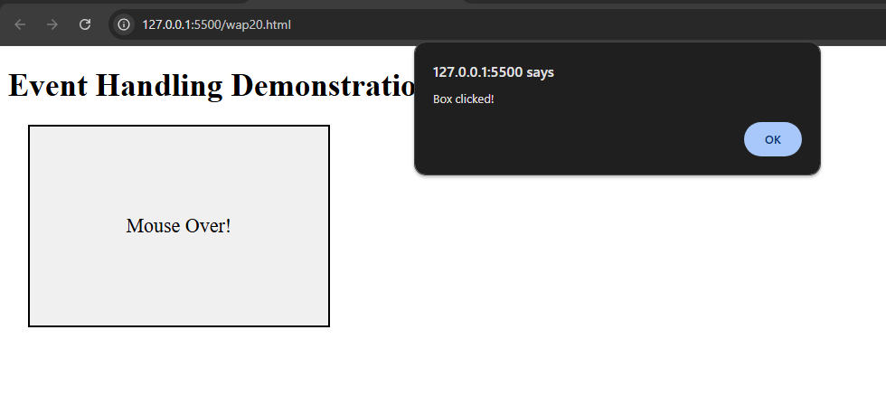

**Program 21 : WAP in JavaScript to demonstrate**

**Blur, Focus, Reset, Submit, Change, load.**

**Code :**

<!DOCTYPE html>

<html lang="en">

<head>

<meta charset="UTF-8">

<meta name="viewport" content="width=device-width, initial-scale=1.0">

<title>Event Handling Example</title>

<style>

body {

font-family: Arial, sans-serif;

margin: 20px;

}

#message {

margin-top: 20px;

font-weight: bold;

}

</style>

</head>

<body>

<h1>Event Handling Demonstration</h1>

<form id="myForm">

<label for="textInput">Input Text:</label>

<input type="text" id="textInput" placeholder="Type something..." required>

<label for="selectInput">Select Option:</label>

<select id="selectInput">

<option value="">--Choose an option--</option>

<option value="option1">Option 1</option>

<option value="option2">Option 2</option>

</select>

<button type="reset">Reset</button>

<input type="submit" value="Submit">

</form>

<div id="message"></div>

<script>

// Load event

window.onload = function() {

console.log("Page loaded successfully!");

};

// Focus event

document.getElementById('textInput').onfocus = function() {

this.style.backgroundColor = '#e0f7fa';

console.log("Input field focused.");

};

// Blur event

document.getElementById('textInput').onblur = function() {

this.style.backgroundColor = '';

console.log("Input field lost focus.");

};

// Change event

document.getElementById('selectInput').onchange = function() {

console.log("Selected option changed to: " + this.value);

};

// Submit event

document.getElementById('myForm').onsubmit = function(event) {

event.preventDefault(); // Prevent actual form submission for demonstration

const messageDiv = document.getElementById('message');

messageDiv.innerHTML = "Form submitted successfully! Input: " + document.getElementById('textInput').value;

console.log("Form submitted.");

};

// Reset event

document.getElementById('myForm').onreset = function() {

const messageDiv = document.getElementById('message');

messageDiv.innerHTML = "Form has been reset.";

console.log("Form reset.");

};

</script>

</body>

</html>

**Output :**

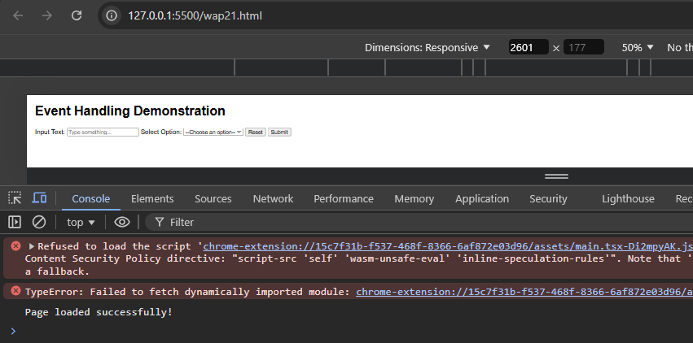

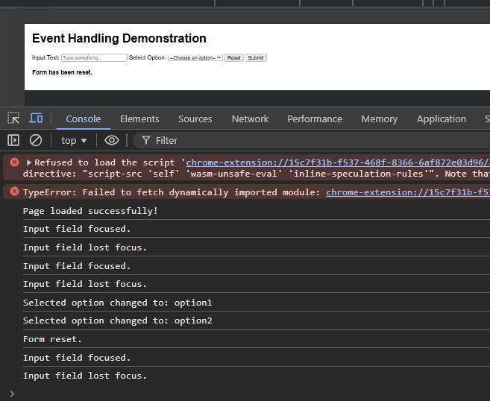

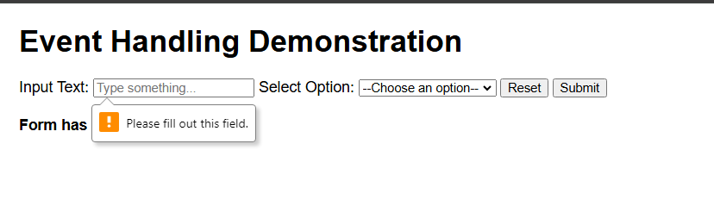

**Program 22 : WAP to implement event handling using :**

**keydown, keyup.**

**Code :**

<!DOCTYPE html>

<html lang="en">

<head>

<meta charset="UTF-8">

<meta name="viewport" content="width=device-width, initial-scale=1.0">

<title>Keydown and Keyup Event Handling</title>

<style>

body {

font-family: Arial, sans-serif;

margin: 20px;

}

#output {

margin-top: 20px;

font-weight: bold;

}

</style>

</head>

<body>

<h1>Keydown and Keyup Event Handling</h1>

<input type="text" id="textInput" placeholder="Type something..." />

<div id="output"></div>

<script>

const textInput = document.getElementById('textInput');

const output = document.getElementById('output');

// Keydown event

textInput.addEventListener('keydown', function(event) {

output.innerHTML = `Key Down: ${event.key} (Code: ${event.code})`;

console.log(`Key Down: ${event.key} (Code: ${event.code})`);

});

// Keyup event

textInput.addEventListener('keyup', function(event) {

output.innerHTML += `<br>Key Up: ${event.key} (Code: ${event.code})`;

console.log(`Key Up: ${event.key} (Code: ${event.code})`);

});

</script>

</body>

</html>

**Output :**

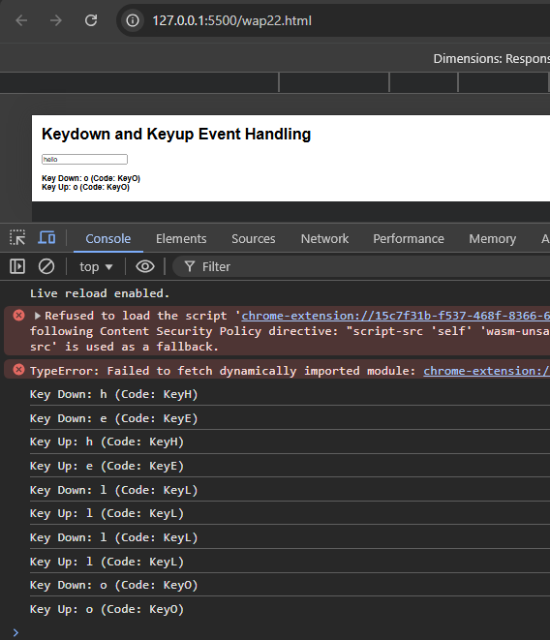

**Program 23: WAP to show JS can change HTML content.**

**Code :**

<!DOCTYPE html>

<html lang="en">

<head>

<meta charset="UTF-8">

<meta name="viewport" content="width=device-width, initial-scale=1.0">

<title>Change HTML Content with JavaScript</title>

<style>

body {

font-family: Arial, sans-serif;

margin: 20px;

}

#output {

margin-top: 20px;

font-weight: bold;

}

</style>

</head>

<body>

<h1>JavaScript Change HTML Content Example</h1>

<p id="myParagraph">This is the original content of the paragraph.</p>

<button id="changeContentButton">Change Content</button>

<div id="output"></div>

<script>

// Function to change the content of the paragraph

function changeContent() {

document.getElementById("myParagraph").innerHTML = "This is the new content of the paragraph!";

document.getElementById("output").innerHTML = "The paragraph content has been changed.";

}

// Adding event listener to the button

document.getElementById("changeContentButton").onclick = changeContent;

</script>

</body>

</html>

**Output :**

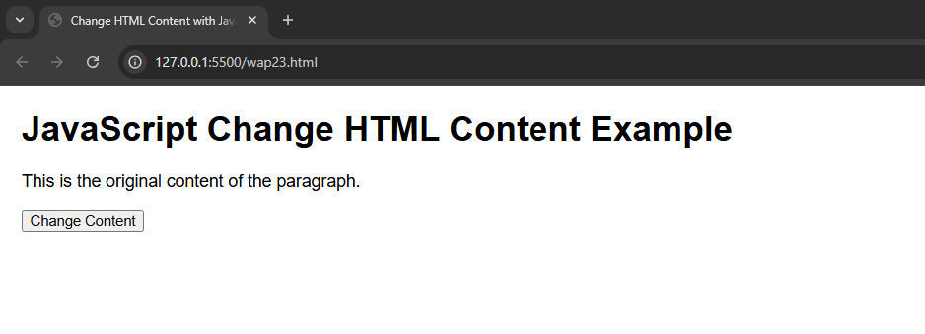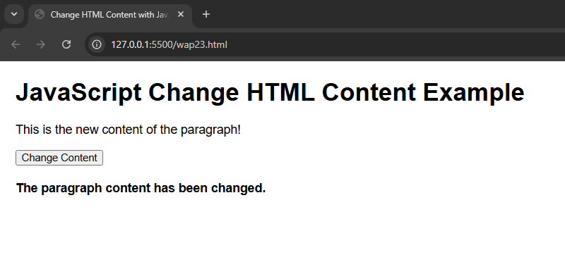

**Program 24: WAP to show JS can change HTML attribute value.**

**Code :**

<!DOCTYPE html>

<html lang="en">

<head>

<meta charset="UTF-8">

<meta name="viewport" content="width=device-width, initial-scale=1.0">

<title>Change HTML Attribute Example</title>

<style>

body {

font-family: Arial, sans-serif;

margin: 20px;

}

#output {

margin-top: 20px;

font-weight: bold;

}

</style>

</head>

<body>

<h1>Change HTML Attribute with JavaScript</h1>

<img id="myImage" src="https://letsenhance.io/static/8f5e523ee6b2479e26ecc91b9c25261e/1015f/MainAfter.jpg" alt="Placeholder Image" width="300" />

<br><br>

<button id="changeImageButton">Change Image</button>

<div id="output"></div>

<script>

// Function to change the src attribute of the image

function changeImage() {

const imgElement = document.getElementById("myImage");

imgElement.src = "https://i0.wp.com/picjumbo.com/wp-content/uploads/silhouette-of-young-blonde-with-short-hair-on-orange-background-free-image.jpeg?h=800&quality=80"; // New image URL

document.getElementById("output").innerHTML = "Image source changed!";

}

// Adding event listener to the button

document.getElementById("changeImageButton").onclick = changeImage;

</script>

</body>

</html>

// Adding event listener to the button

document.getElementById("changeImageButton").onclick = changeImage;

</script>

</body>

</html>

**Output :**

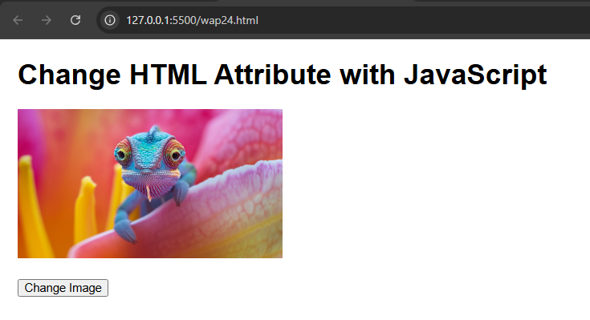

**Program 25 : WAP to show JS can change HTML style.**

**Code :**

<!DOCTYPE html>

<html lang="en">

<head>

<meta charset="UTF-8">

<meta name="viewport" content="width=device-width, initial-scale=1.0">

<title>Change HTML Style with JavaScript</title>

<style>

body {

font-family: Arial, sans-serif;

margin: 20px;

}

#myParagraph {

padding: 10px;

border: 1px solid #000;

width: 300px;

text-align: center;

}

</style>

</head>

<body>

<h1>Change HTML Style with JavaScript</h1>

<p id="myParagraph">This is a paragraph whose style will change.</p>

<button id="changeStyleButton">Change Style</button>

<script>

// Function to change the style of the paragraph

function changeStyle() {

const paragraph = document.getElementById("myParagraph");

paragraph.style.backgroundColor = "#FF5733"; // Change background color

paragraph.style.color = "#FFFFFF"; // Change text color

paragraph.style.fontSize = "20px"; // Change font size

paragraph.style.borderRadius = "5px"; // Add border radius

}

// Adding event listener to the button

document.getElementById("changeStyleButton").onclick = changeStyle;

</script>

</body>

</html>

**Output :**

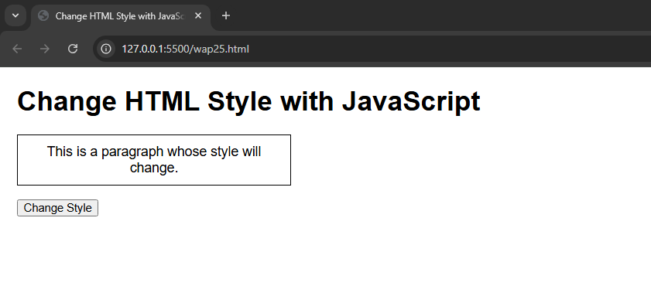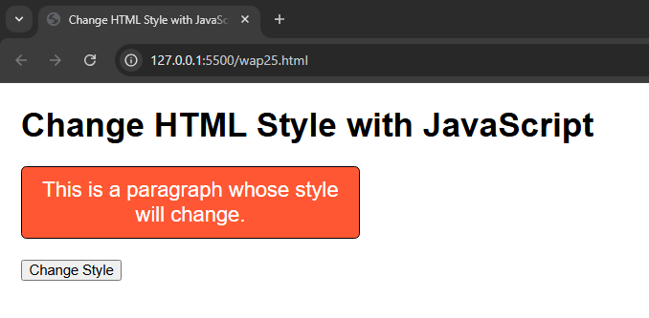

**Program 26 : WAP to show use of Window Object in JS.**

**Navigation object, JavaScript Screen Object, Set-time function.**

**Code :**

<!DOCTYPE html>

<html lang="en">

<head>

<meta charset="UTF-8">

<meta name="viewport" content="width=device-width, initial-scale=1.0">

<title>Window Object Example</title>

<style>

body {

font-family: Arial, sans-serif;

margin: 20px;

}

#output {

margin-top: 20px;

font-weight: bold;

}

</style>

</head>

<body>

<h1>Demonstration of Window Object in JavaScript</h1>

<button id="navButton">Show Navigation Info</button>

<button id="screenButton">Show Screen Info</button>

<button id="setTimeoutButton">Set Timeout Example</button>

<div id="output"></div>

<script>

// Function to show Navigation object information

function showNavigationInfo() {

const navInfo = `

User Agent: ${navigator.userAgent}<br>

Language: ${navigator.language}<br>

Online Status: ${navigator.onLine ? 'Online' : 'Offline'}

`;

document.getElementById("output").innerHTML = `<strong>Navigation Info:</strong><br>${navInfo}`;

}

// Function to show Screen object information

function showScreenInfo() {

const screenInfo = `

Screen Width: ${screen.width}px<br>

Screen Height: ${screen.height}px<br>

Available Width: ${screen.availWidth}px<br>

Available Height: ${screen.availHeight}px<br>

Color Depth: ${screen.colorDepth} bits<br>

Pixel Depth: ${screen.pixelDepth} bits

`;

document.getElementById("output").innerHTML = `<strong>Screen Info:</strong><br>${screenInfo}`;

}

// Function to demonstrate setTimeout

function setTimeoutExample() {

document.getElementById("output").innerHTML = "Waiting for 3 seconds...";

setTimeout(() => {

document.getElementById("output").innerHTML = "3 seconds have passed!";

}, 3000);

}

// Adding event listeners to buttons

document.getElementById("navButton").onclick = showNavigationInfo;

document.getElementById("screenButton").onclick = showScreenInfo;

document.getElementById("setTimeoutButton").onclick = setTimeoutExample;

</script>

</body>

</html>

**Output :**

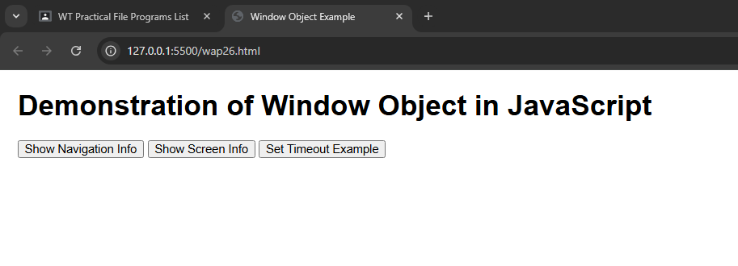

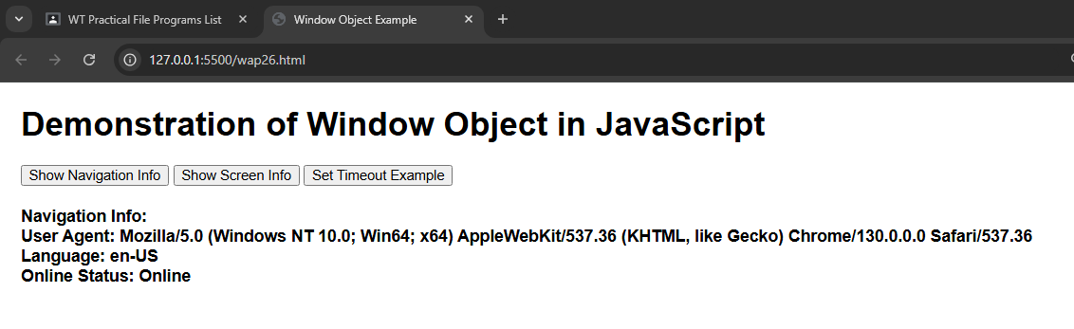

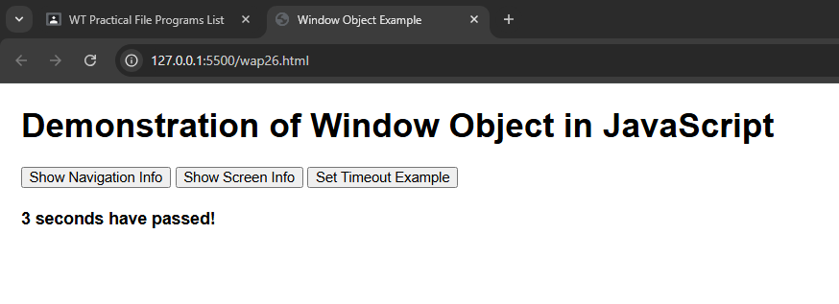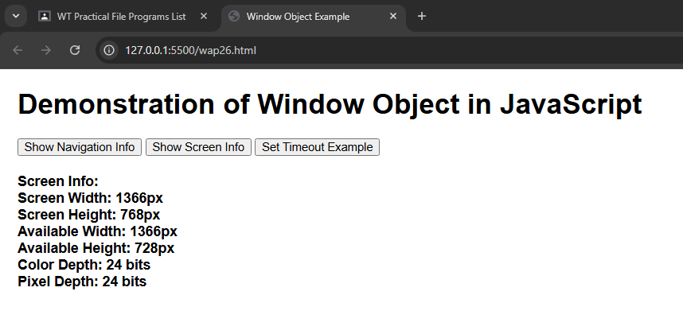

**Program 27 : Create an XML file containing note as the root element and to, from, subject and body as its child element.**

**Code :**

<?xml version="1.0" encoding="UTF-8"?>

<note>

<to>Krishna</to>

<from>Happy</from>

<subject>Exam reminder</subject>

<body>Don't forget our exam tomorrow at 10 AM.</body>

</note>

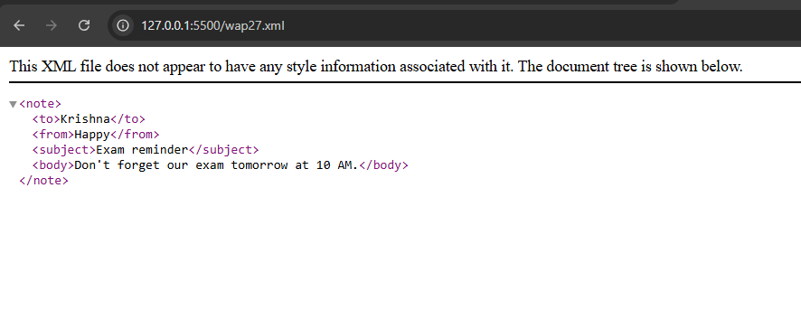**OUTPUT :**

**Program 28 : Create a well-formed XML file having 5 tags-food menu, category, name, price and calories. Food_menu is the main parent element that contains category as the child element. Category is the parent element of name, price and calories.**

**Code :**

<?xml version="1.0" encoding="UTF-8"?>

<food_menu>

<category>

<name>Grilled Chicken Sandwich</name>

<price>5.99</price>

<calories>450</calories>

</category>

<category>

<name>Veggie Wrap</name>

<price>4.49</price>

<calories>320</calories>

</category>

<category>

<name>Cheeseburger</name>

<price>6.49</price>

<calories>700</calories>

</category>

<category>

<name>Caesar Salad</name>

<price>3.99</price>

<calories>220</calories>

</category>

<category>

<name>Chocolate Milkshake</name>

<price>2.99</price>

<calories>600</calories>

</category>

</food_menu>

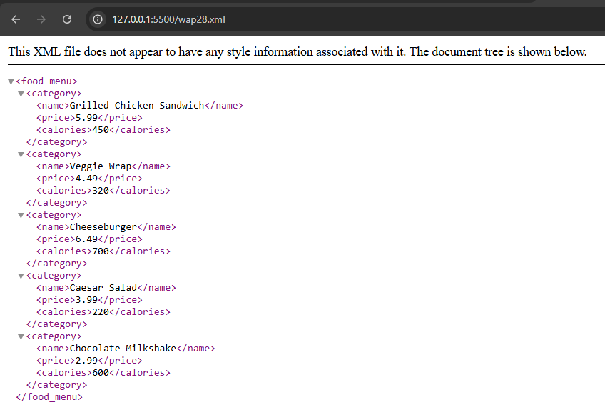**OUTPUT :**

**Program 29 : WAP to display the bookstore details in XML with CSS and internal DTD.**

**CODE :**

<?xml version="1.0" encoding="UTF-8"?>

<!DOCTYPE bookstore [

<!ELEMENT bookstore (book+)>

<!ELEMENT book (title, author, price, isbn)>

<!ELEMENT title (#PCDATA)>

<!ELEMENT author (#PCDATA)>

<!ELEMENT price (#PCDATA)>

<!ELEMENT isbn (#PCDATA)>

]>

<?xml-stylesheet type="text/css" href="style12.css"?>

<bookstore>

<book>

<title>The Great Gatsby</title>

<author>F. Scott Fitzgerald</author>

<price>$10.99</price>

<isbn>9780743273565</isbn>

</book>

<book>

<title>1984</title>

<author>George Orwell</author>

<price>$8.99</price>

<isbn>9780451524935</isbn>

</book>

<book>

<title>To Kill a Mockingbird</title>

<author>Harper Lee</author>

<price>$7.99</price>

<isbn>9780061120084</isbn>

</book>

</bookstore>

**STYLE12.css**

bookstore {

display: block;

font-family: Arial, sans-serif;

}

book {

display: block;

margin-bottom: 15px;

padding: 10px;

border: 1px solid #ccc;

background-color: #f9f9f9;

}

title {

display: block;

font-size: 1.5em;

font-weight: bold;

color: #333;

}

author, price, isbn {

display: block;

margin: 5px 0;

}

**OUTPUT :**

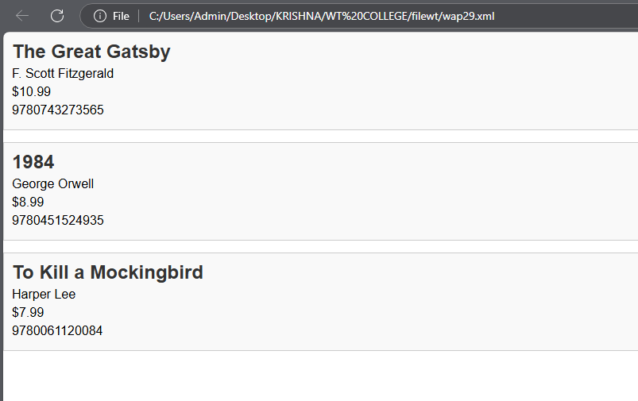

**Program 30 : Create Valid XML doc using external DTD.**

**CODE :**

<?xml version="1.0" encoding="UTF-8"?>

<!DOCTYPE bookstore SYSTEM "bookstore.dtd">

<bookstore>

<book>

<title>The Great Gatsby</title>

<author>F. Scott Fitzgerald</author>

<price>10.99</price>

<isbn>9780743273565</isbn>

</book>

<book>

<title>1984</title>

<author>George Orwell</author>

<price>8.99</price>

<isbn>9780451524935</isbn>

</book>

<book>

<title>To Kill a Mockingbird</title>

<author>Harper Lee</author>

<price>7.99</price>

<isbn>9780061120084</isbn>

</book>

</bookstore>

**BOOKSTORE.DTD :**

<!ELEMENT bookstore (book+)>

<!ELEMENT book (title, author, price, isbn)>

<!ELEMENT title (#PCDATA)>

<!ELEMENT author (#PCDATA)>

<!ELEMENT price (#PCDATA)>

<!ELEMENT isbn (#PCDATA)>

**OUTPUT :**

